Document ID: 01_25_11_1
Date Received: 01_25_11 Date Revised: 04_18_11 Date Accepted: 05_04_11
Grade Level: Middle and High School (7-12)
Curriculum Topic Benchmarks: S12.3.7, S12.4.6, S12.4.7, S13.3.2, S13.4.6, S14.3.2, S14.3.4, S14.4.2, M8.3.1, M8.3.3, M8.3.4, M8.3.5, M8.3.9, M8.3.11, M8.3.12, M8.4.16. M9.3.1, M9.4.7
Subject Keywords: tide, gravitation, Newton, solid earth tides, ocean tides, Moon
Rating: Advanced

Why Is There a Tidal Bulge Opposite the Moon?

By: Stephen J Edberg, Jet Propulsion Laboratory, California Institute of Technology, 4800 Oak Grove Drive, M/S 321-520, Pasadena CA 91011
e-mail: Stephen.J.Edberg@jpl.nasa.gov

From: The PUMAS Collection http://pumas.jpl.nasa.gov
©2011, Jet Propulsion Laboratory, California Institute of Technology. ALL RIGHTS RESERVED.

Most everyone is aware that the Moon causes ocean tides on Earth, and coastal inhabitants usually have firsthand knowledge. A long day at the beach or a look through tide tables will demonstrate that there are usually two high tides or two low tides each day, and that they shift through time-of-day as the calendar advances.

There is a high tide on the Moon-side of Earth because of the Moon’s gravitational effect on Earth (and the ocean water), but why should there be a bulge of water on the opposite side of Earth, making two high tides separated by a little more than 12 hours every 24 hours?

OBJECTIVE: Use mathematics to understand tides and gravitation and how gravity works across astronomical distances.

APPARATUS & PREPARATION:

- Slinky-type “lazy” spring, metal or plastic. The slinky should be short enough that it won’t touch the floor while hanging from a height great enough for students to see it from their seats.
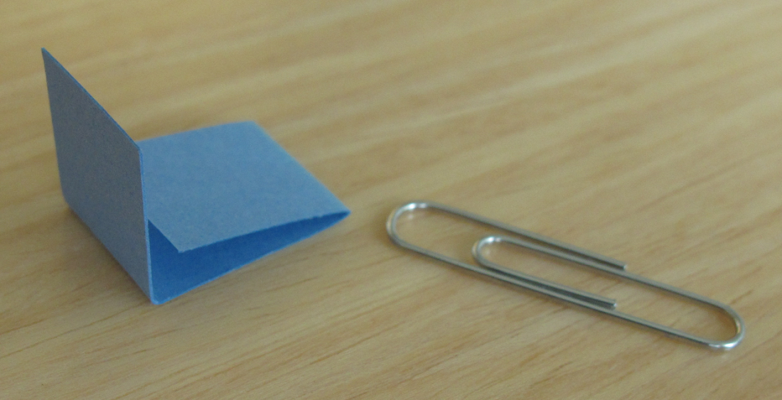
- “Flags” (5 required, Fig. 1) to mark coils of the slinky spring. Fold strips of notecard to make each flag, large enough to be individually visible from the back of the classroom. Staple, paper-clip, or tape each flag around an individual slinky coil. Attach five flags that are separated in this pattern: flag-2 coils-flag-15 coils-flag-15 coils-flag-2
Fig. 1. A simple flag.
coils-flag, centered roughly on the middle of the coil.

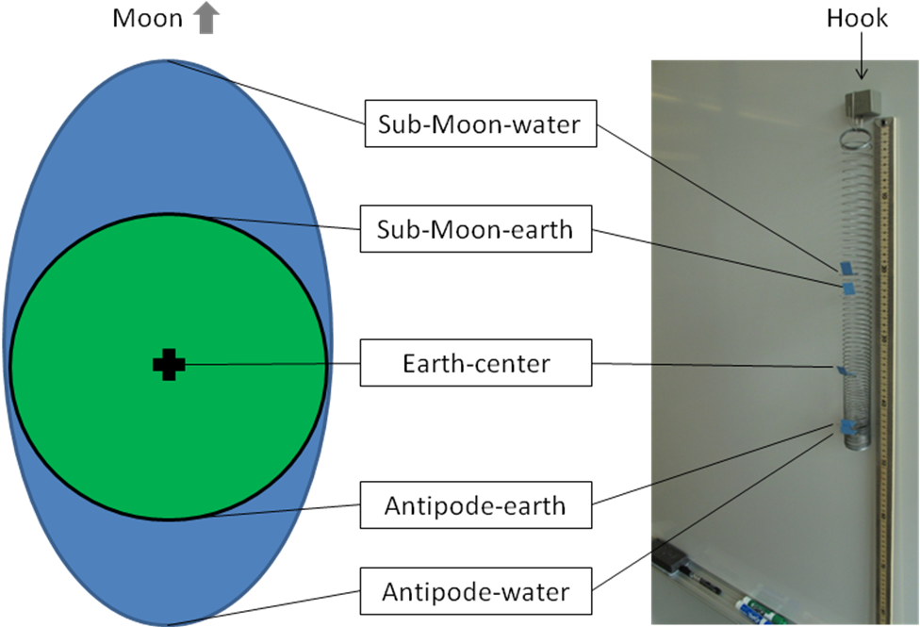
Fig. 2. Earth’s tidal bulges of water are illustrated on the left, very much not to scale. A slinky hanging from a hook held by a magnet on a white board is on the right. The names of the important points in the discussion and calculations are presented in between.

The outermost flags (Fig. 2) are called sub-Moon-water and antipode∗-water). The flags inside each are sub-Moon-earth and antipode-earth flags, respectively, with the Earth-center flag in the middle of the flag set. Feel free to adjust the separations for the best visibility, maintaining the symmetric placement of the flags. The outer flag pairs represent sea level and the solid Earth’s surface and the middle flag represents Earth’s center. The middle flag should be near the middle of the Slinky if possible.
- Meter stick (Fig. 2) or yardstick to measure the separations of the flags when the slinky is hanging without motion. The meter stick (or a rod or scrap of PVC pipe) can also be used to hold the slinky horizontally (Fig. 3) to remove the effects of gravity for part of the demonstration.
- A hook is necessary to hang the coil (Fig. 2) for the demonstration. It can be placed anywhere convenient (light fixture, white board, etc.) and deep enough to hold a several coils while the rest of the spring hangs down, motionless. Make sure the Slinky hangs high enough so that students at the back of the room can see all five flags above desks and heads.

PROCEDURE:

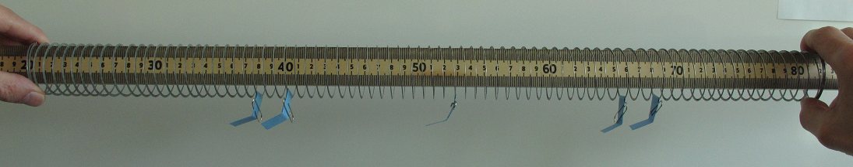
Start by spreading the coil with both hands as it hangs on a rod held horizontally (Fig. 3). Point out (or measure) the equal separations of the (sub-Moon water flag – sub-Moon Earth flag) and the (antipode-Earth flag – antipode water flag) pair and the equal separations of the (sub-Moon Earth flag – center flag) and the (center flag – antipode Earth-flag) pair. The coil between the water flags represents Earth’s self-gravity. Letting go of the ends of the coil will prove the point as the coil collapses on itself (Fig. 4).
Fig. 3. The coil stretched horizontally, representing the Earth and its oceans alone in space.

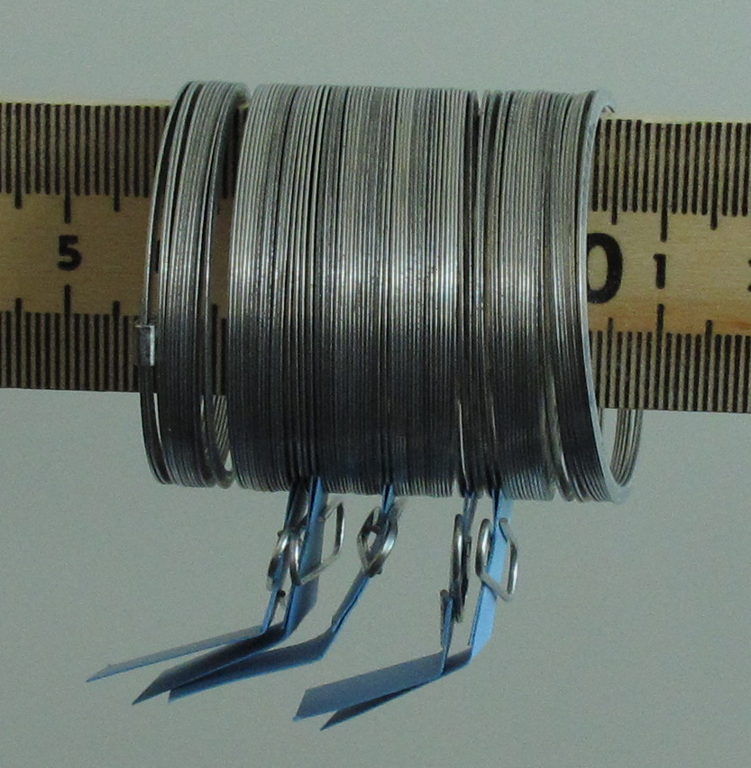
Hang the coil vertically from the hook (Fig. 5) in front of the students and discuss what they are seeing now. They should note that the distances separating the flags are all different magnitudes (even if one separation is matched to its horizontal separation). Separations of the water-Earth surface flag pairs at the top and bottom will be different, as will the separations of the pairs of Earth surface-center flags. The upper two spacings are greater than their respective lower two spacings even though the number of coils is the same. Remind the students that the hanging coil, between the outer flags, now represents Earth and its oceans, under the influence of its own gravity (self-gravity) and the gravity of the Moon (the hook holding the coil up, not Earth’s real gravity towards the floor). Ask for an explanation of the pattern of separation.
Fig. 4. The collapsed coil.

Answer: When stretched vertically (by hanging from the hook) an outside body (the hook and the slinky above the top flag) is applying a force on the rest of the slinky to hold it in place. Measuring the positions of the flags demonstrates that there is a different amount of force stretching the slinky along its length. This is analogous to the decrease in the force of gravity with distance from an outside mass. (Note that we don’t feel this difference if we lift a hand-weight at sea level and again on top of a mountain or in an airplane. The change in distance from Earth’s center is just too little for our muscles to feel the difference, though it can be measured with instruments.)

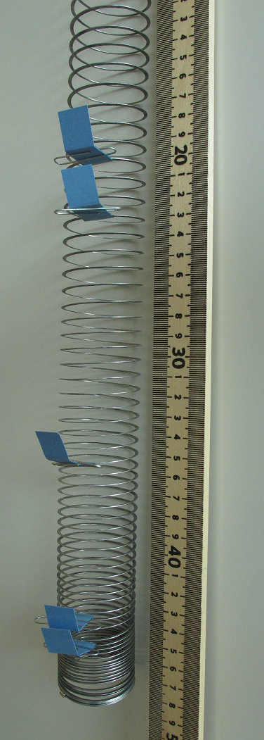
THE UNDERLYING PRINCIPLES:

The force of gravity diminishes with distance. Because of this, the force of gravity is different, and measurably so, from the first floor of a building (stronger) to the top floor of the building (weaker, because it is farther from the center of the Earth).

Tides may be defined as the difference of the gravitational attraction of an outside object through another (nearby) object. In the Earth-Moon system, the strength of the Moon’s attraction is:

- Greatest on Earth’s surface directly “below” the Moon (Moon at the zenith), called the sub-Moon point
- Weaker at Earth’s center and
- Weakest at the antipode, the point on Earth’s surface on the line from the Moon through Earth’s center to the far surface.

If one now thinks of the Earth as falling towards the Moon due to the Moon’s gravitational attraction, the sub-Moon point has a greater force on it than the center, which has a greater force on it than the antipode. So water (and the solid-earth surface) on the Moon-side falls towards the Moon faster than the center which falls faster than the antipode water (and solid-earth surface there). The antipode water is being left behind by the center, which is being left behind by sub-Moon water. Back on Earth, we see these as two bulges of water which we call tides (and we can measure solid-earth tides as well).
Fig. 5. The hanging Slinky. Note the separation of the flags.

It is important to understand that in this demonstration, although Earth’s gravity is stretching the slinky down, the important analogy is that the restoration force of the spring acting through the hook is the equivalent of the Moon’s gravity acting upon Earth. (Between the top and bottom flags, the spring represents Earth’s self-gravity combined with some lunar gravity). The restoration force along the hanging slinky changes (decreases closer to the floor) because the coil near the hook has more coils below it, and their weight exerts a greater force than do the smaller number of coils that pull downward on an individual coil lower down. Sketches of the gravitational force vectors involved (lunar and Earth self-gravity) at the sub-Moon point, Earth center, and antipode may help illuminate the forces individually and their sums.

By studying tide tables for various places, you can see that the behavior of lunar tides is not nearly as simple as the analogy and the physical/mathematical calculations in the DISCUSSION section demonstrate. Additional complications include:
- Solar tides, which can sum with the lunar tide to increase or reduce the bulges of water, creating a spring tide (Sun, Earth, Moon aligned) or a neap tide (Sun, Earth, Moon make 90 degree angle).
- The varying physical distances of the Moon and Sun, demonstrated by higher tides in December-January. Earth is closest to the Sun in early January.
- The varying angular distances of the sub-Moon and sub-Sun points above and below Earth’s equator, varying the position of the bulge over the year.
- The topography of the ocean floor near shoreline monitoring stations.
- The effects of wind and weather systems on the ocean’s surface (for example, a hurricane storm surge may add to the astronomical tide, causing a “storm tide”).
The first three involve vector addition of gravitational forces.

Technical note: The spring analogy should not be pushed too far. Measurements made with the spring will not match the gravitational calculations in the DISCUSSION section, next. The restoration force for a spring is linear (not inverse-squared, as it is for gravity). It is given by F = -k x r, where k is the spring constant (different for lazy springs and stiff springs) and r is a measure of the extension. The minus sign indicates that the restoration force is in the direction opposite the extension of the spring.

DISCUSSION:

The following table includes definitions and values of constants and variables for the calculations that follow.

Table 1: Definitions and Values
Symbol | Variable or Constant Name | Definition | Value | Units
F | Force | A cause of a change in motion, here gravity | Calculated | kg km/s²
G | Gravitational Constant | Conversion factor | 6.674 x 10⁻¹⁷ | N km²/kg²
m₁ | Mass #1 | Defined to be a unit mass, 1 kg, in this activity. Usually a variable used to determine the force of gravity between two bodies of masses m₁ and m₂. | 1 | kg
m₂ | Mass #2 | Mass of the Moon in this activity. | 7.3490 x 10²² | kg
r | Separation Distance (Earth-Moon) | The separation between two objects gravitationally influencing each other. |  | km
a | Earth-Moon separation | This is the average Earth-Moon distance, center-to-center, for this activity. | 384400 | km
R | Earth's radius | The distance from Earth's center to its surface. | 6378.14 | km
We want to compare the difference in the Moon’s pull on Earth’s center with its pull on the antipode point and on the sub-Moon point.
(0a) We can rewrite Newton’s Law of Gravitation, F = G x (m₁) x (m₂)/r².

Calculating Gravitational Acceleration:
(0b) In units, the force based on equation (0a) is [kg m/s²] = [N km²/kg²][kg][kg]/[km²] which reduces to
(0c) [kg m/s²] = [N] when all the kg’s and km’s that cancel are taken into account.

To calculate acceleration, divide both sides of equation (0a) by m₁ (or divide by kg in the units equation (0b)):

(1) Gravitational acceleration = F/(m₁) = G x (m₂)/r², where m₁ is taken to be a unit mass, G is the gravitational constant 6.674 x 10⁻¹⁷ (N km²/kg²).

(2) Earth’s center’s gravitational acceleration due to the Moon = G x (m₂)/a² = 3.319 x 10⁻⁵ km/s², where m₂ is the mass of the Moon = 7.3490 x 10²² kg, and a² = (384400)² km².

(3) Antipode gravitational acceleration due to the Moon = G x (m₂)/(a+R)² = 3.212 x 10⁻⁵ km/s². This is smaller than in (2) because the antipode is one Earth radius, R = 6378.14 km, farther than Earth’s center from the Moon, so the denominator is larger.

(4) The difference in acceleration for Earth’s center and the antipode is 1.07 x 10⁻⁶ km/s².

(5) The sub-Moon point’s gravitational acceleration due to the Moon = G x (m₂)/(a-R)² = 3.432 x 10⁻⁵ km/s². This is larger than in (2) because the sub-Moon point is one Earth radius, R = 6378.14 km, closer than Earth’s center to the Moon, so the denominator is smaller.

(6) The difference in acceleration for the sub-Moon point and Earth’s center is 1.13 x 10⁻⁶ km/s².

The result in (4) is different from the result in (6) because the force of gravity decreases as the square of the distance. As shown, there is a calculable difference in the forces and in the differential forces at the sub-Moon, center, and antipode points. The slinky illustrates that the water bulge is larger in the sub-Moon hemisphere and smaller in the antipode hemisphere, reflecting both the calculations and the unrealistic situation of a perfectly smooth Earth completely covered with water.

EXTENSION 1:

Students can actually calculate solar tides, the difference in the force of gravity at the same three points (sub-Sun, Earth center, Sun-antipode) on the Sun-Earth line, based on the differences in their distances to the Sun’s center. The steps are the same, (1) – (6) as for the lunar tides computed in the DISCUSSION above. For solar tides, the mass of the Sun is substituted for the mass of the Moon and the semi-major axis of Earth’s orbit is substituted for the Moon’s distance in the calculations. Values are provided in Table 2 below.

Ocean and solid earth tides vary in magnitude because
- the Moon’s distance from Earth varies during its orbital revolution,
- the Sun’s distance from Earth varies during its orbital revolution, and
- (a) the alignment of Sun and Moon varies because of the Moon’s orbital motion and (b) because its orbit is in a different plane that is tilted with respect to Earth’s orbit around the Sun.

If desired, students can calculate the gravitational accelerations due to these maximum and minimum differences in the distance of Earth from the Sun and the distance of Earth from the Moon. The formulas for periapsis (defined in Table 2; called perigee of the Moon’s orbit and perihelion of the Earth’s orbit) and apoapsis (apogee of the Moon, aphelion of the Earth) follow Table 2.

Table 2: Extension 1 Definitions and Values
Symbol | Variable Name | Definition | Value | Units
q | Periapsis Distance | The distance from the focus of an ellipse holding the more massive of a pair of masses to the closest point of the orbital ellipse. | -- | distance, km for this calculation
Q | Apoapsis Distance | The distance from the focus of an ellipse holding the more massive of a pair of orbiting masses to the farthest point of the orbital ellipse. | -- | distance, km for this calculation
a | Semi-major axis of an ellipse | The semi-major axis is one-half of the longest "diameter" of an ellipse. | -- | distance, km for this calculation
 | Semi-major axis of Earth's orbit |  | 1.496 x 10⁸ | km
 | Semi-major axis of Moon's orbit |  | 384400 | km
e | Eccentricity | Eccentricity is the degree of ellipticity of an ellipse - how stretched it is. The value ranges from 0 (a perfect circle) and 1 (an open parabola). | -- | (unitless; it is a ratio)
 | Eccentricity of Earth's orbit |  | 0.01671123 | (unitless; it is a ratio)
 | Eccentricity of Moon's orbit |  | 0.0554 | (unitless; it is a ratio)

Illustrated below (Figure 6), the
Periapsis of an elliptical orbit = q = a x (1 + e), called perihelion for Earth’s orbit and perigee for the Moon’s orbit, and
Apoapsis of an elliptical orbit = Q = a x (1 - e), called aphelion for Earth’s orbit and apogee for the Moon’s orbit. The definitions of the variables are
a = the semi-major axis of the ellipse and
e = the eccentricity of the ellipse.
Both a and e are orbital elements that describe the shape and orientation of an orbit.

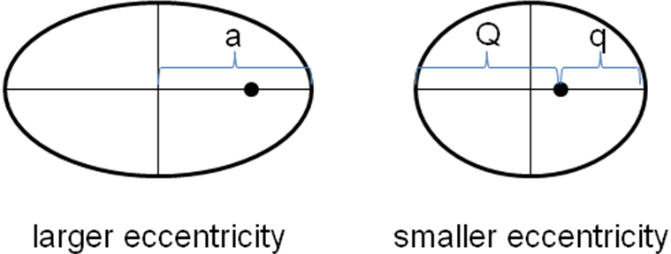
Fig. 7. These ellipses represent orbits with greater or lesser eccentricity. The black dot indicates the focus of the ellipse, where the “primary” of an orbiting system (e.g., the Sun for the planets or the Earth for the Moon) resides. The semi-major axis is the length “a”. The periapsis distance is “q” and the apoapsis distance is “Q”. All three, a, q, and Q, are different in the two ellipses presented.

EXTENSION 2:

In the Solar System, the Moon and Earth trace different amplitude sinusoidal waves as their mutual center of mass (CM) orbits the Sun smoothly. They revolve around each other much as an unbalanced dumbbell would spin: the light end makes a large circle while the heavy end makes a small circle about the dumbbell’s center of mass. More specifically, the Moon’s center has a large orbit around the Earth-Moon center of mass and the Earth’s center has a small orbit around the Earth-Moon center of mass (Figure 8). (This last sentence is an oversimplification of the Earth-Moon system. See Edberg [2005] for a discussion and demonstration.)

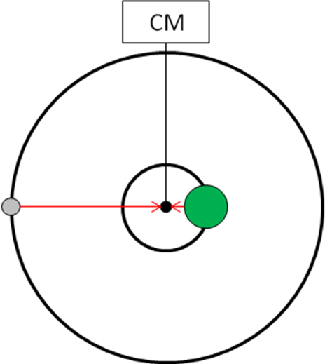
Some sources explain that the water bulge on the antipode hemisphere is due to the centrifugal force of the Earth (at the antipode point) swinging around the Earth-Moon center of mass. It is not difficult to demonstrate that this effect is minor compared to the differential gravitational effects presented in the DISCUSSION above. The following table includes definitions and values of constants and variables for the calculations below that demonstrate this.

Fig. 8. When a less massive object orbits a more massive object, they are both actually orbiting their mutual center of mass (CM). This diagram illustrates the effect for a circular orbit, but the effect holds true for elliptical orbits (and even parabolic and hyperbolic orbits).

Table 3: Extension 2 Definitions and Values
Symbol | Variable or Constant Name | Definition | Value | Units
F; F_{c} | Force | Any cause of a change in motion. Centrifugal force, F_{c}, is fictitious but is genuinely experienced on rotating and revolving bodies. | Calculated | kg km/s²
a; a_{c} | Acceleration | A change in speed over time. Centrifugal acceleration, a_{c}, is the corresponding acceleration for centrifugal force. | Calculated | km/s²
G | Gravitational Constant | Conversion factor | 6.674 x 10⁻¹⁷ | N km²/kg²
m, m₁ | Mass #1 | Any mass. m₁ is defined to be a unit mass, 1 kg, in this activity. Usually these variables are used to determine the force of gravity between two bodies of masses m₁ and m₂. | 1 | kg
m₂ | Mass #2 | Mass of the Sun in Extension 2 | 1.9891 x 10³⁰ | kg
v | Speed | Rotation speed (linear) of a spinning object or revolution speed of a revolving object. | Calculated | km/s
r | Separation Distance (Earth-Sun) | Average Earth-Sun distance, center-to-center, for Extension 2. | 1.496 x 10⁸ | km
R | Earth's radius | The distance from Earth's center to its surface. | 6378.14 | km
CM |  | Center of Mass: the point (usually inside a body) that behaves mathematically as if all the mass of the body were contained there.
CM offset |  | The distance of the Earth-Moon CM from Earth’s surface.
π | pi | The mathematical constant pi | 3.1416, approximately | pure number

We can demonstrate this with Newton’s Laws: His 2nd Law states that F = m x a and his Law of Gravitation states that F = G x (m₁) x (m₂)/r².

(7) Centrifugal force, although “fictitious,” can be computed with F_{c} = (m x v²)/r.

Equation (7) can be rewritten to define an acceleration (since one can assume that the same mass of water will be used in this comparison):

(8) Centrifugal acceleration a_{c} = F_{c}/m = (v²)/r .

The velocity, v, of the antipode point is calculated from the circumference of its orbit divided by the duration of the orbit.

(9) Radius of antipode orbit is the distance of the antipode point from the Earth-Moon CM (Figure 7). The antipode orbital radius = (2 x (Earth’s radius) – (distance of the Earth-Moon CM from Earth’s surface)). The distance of the Earth-Moon CM from Earth’s surface is called the CM offset.

Earth’s equatorial radius is 6378.14 km, and the Nova website gives the distance of the Earth-Moon CM offset as 1070 mi = 1722 km below Earth’s surface.

(10) Radius of the antipode’s orbit = 11034.28 km

(11) Circumference of the antipode’s orbit = (2 x π x 11034.28) = 69330.44 km

The Moon and Earth orbit their CM in 27.322 days (a period shorter than the time from full moon to full moon because it is based on in an inertial system fixed on quasars, not on the Sun). There are 86400 seconds in a day so the speed is

(12) v = circumference/time = 69330.44/(27.322 x 86400) = 0.0294 km/s

Using (8), the acceleration due to the centrifugal force is

(13) a_{c} = (0.0294)²/11034.28 = 7.8 x 10⁻⁸ km/s².

Recall DISCUSSION calculation (4). The difference in Earth Center-Antipode acceleration is 1.07 x 10⁻⁶ km/s², which is almost 14 times greater than the acceleration due to CM centrifugal force. (For completeness: From DISCUSSION calculation (6) the difference in acceleration sub-Moon-Earth Center is 1.13 x 10⁻⁶ km/s², which is 14.5 times greater than the acceleration due to CM centrifugal force.)

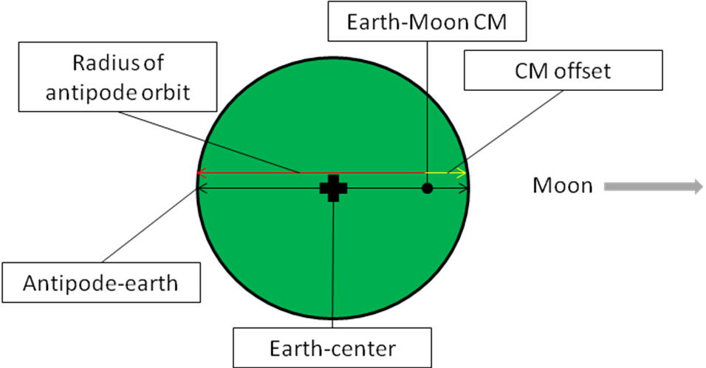
Fig. 7. The red arrow illustrates the radius of the antipode’s orbit around the Earth-Moon center of mass (CM). The CM offset is the short distance between the CM and Earth’s surface in the direction of the Moon.
(14) The total acceleration at the antipode is the sum of the tidal acceleration in (4) plus the centrifugal acceleration in (13), 1.07 x 10⁻⁶ km/s² + 7.8 x 10⁻⁸ km/s² = 1.148 x 10⁻⁶ km/s²

(15) Dividing the result in (4) by the result in (14), 1.07 x 10⁻⁶/1.148 x 10⁻⁶, one can conclude that differential lunar gravity, the Moon’s tide, is the cause of more than 93% of the antipode water bulge.

FOR MORE INFORMATION:

Tidal Curiosities: http://www.pbs.org/wgbh/nova/venice/tide_curiosities.html

REFERENCES:

Edberg, S. J., 2005, The Moon Orbits the Sun?!?!, PUMAS, https://pumas.gsfc.nasa.gov/examples/index.php?id=86

Constants, masses, and orbital values came from the Observer’s Handbook 2011 of the Royal Astronomical Society of Canada, which also includes a chapter on tides. Conversion to km from meters followed majority rule among the units needed in the calculations.

ACKNOWLEDGMENT:

I am grateful to the NSTA earth science listserv and to PBS’ Nova website for the motivation to prepare this activity. Joe Catanzarite assisted with the photographs.

Calculations were made on an ancient HP67 RPN calculator [ENTER > = ].

This publication was prepared by the Jet Propulsion Laboratory, California Institute of Technology, under a contract with the National Aeronautics and Space Administration.

Reference herein to any specific commercial product, process, or service by trade name, trademark, manufacturer, or otherwise, does not constitute or imply its endorsement by the United States Government or the Jet Propulsion Laboratory, California Institute of Technology.

 Antipode (an-teh-pode) refers to a point diametrically opposite some other specified point on a globe.

