Document ID:
Date Received: Date Revised: Date Accepted:
Curriculum Topic Benchmarks: M4.4.8, M5.4.12, M8.4.2, M8.4.15, S15.4.4, S16.4.3
Grade Level: High School [9-12]
Subject Keywords: circumference, radius, Eratosthenes, gnomon, sun dial, Earth, noon, time zone, latitude, longitude
Rating:

How Big Is the Earth?

By: Stephen J Edberg, Jet Propulsion Laboratory, California Institute of Technology, 4800 Oak Grove Drive, M/S 183-301, Pasadena CA 91011
e-mail: Stephen.J.Edberg@jpl.nasa.gov

From: The PUMAS Collection http://pumas.jpl.nasa.gov
©2013, Jet Propulsion Laboratory, California Institute of Technology. ALL RIGHTS RESERVED.

Eratosthenes, the third librarian of the Great Library of Alexandria, measured the circumference of Earth around 240 B.C.E. Having learned that the Sun passed through the zenith on the summer solstice as seen in modern day Aswan, he measured the length of a shadow on the solstice in Alexandria. By converting the measurement to an angle he determined the difference in latitude – what fraction of a circle spanned the separation – between Aswan and Alexandria. Knowing the physical distance between Aswan and Alexandria allowed him to determine the circumference of Earth.

Cooperating schools can duplicate Eratosthenes’ measurements. Sharing their data permits students to calculate the circumference and the radius of Earth. The measurements do not require a site on the Tropic of Cancer (or the Tropic of Capricorn) but they must be made at local solar noon on the same date.

OBJECTIVE: Work with another school a significant distance from your school. It should be as close to due north or south of your campus as possible. Make measurements of the lengths of shadows on the same date local noon. From these measurements, determine the circumference and radius of Earth.

APPARATUS: (1) Build and install, or find on campus, a gnomon (pronounced noh-mun) to use for the measurements of the length of the shadow. Your gnomon may be as simple as a dowel, flag pole, volley ball net support, or fence post. It is important that it be truly vertical. A circular cross-section is desirable so the end of the shadow is easily interpreted. Higher gnomons are more impressive but also have “fuzzier,” less distinct shadows at their ends, making the length measurement more ambiguous. Use a carpenter’s level to make measurements 90° around the gnomon to verify the gnomon is truly along a radius from Earth’s center (i.e., vertical, perpendicular to the ground).
- A tape measure will be used to measure the height of the gnomon and the length of its shadow on the same plane as its base.
- A scientific calculator (or spreadsheet) for each student or group of students.
- If desired: A sundial will provide local solar noon for any time during the day(light). If measurements are made at solar noon, the gnomon itself serves as a sun dial.
- Alternate approach to calculate the clock time of noon: Map or a Global Positioning System (GPS) unit is used to determine your school’s latitude and longitude. See THE UNDERLYING PRINCIPLES.
- For EXTENSION activity only: Determine latitude at night using a protractor, thread or fishing line, and a spare hexagonal nut or a few paperclips serving as a plumb bob on the thread. Be sure the thread pivots on the measuring center of the protractor, as illustrated in Figure 1. Make photocopies of the protractor on card stock and distribute the parts to all students.
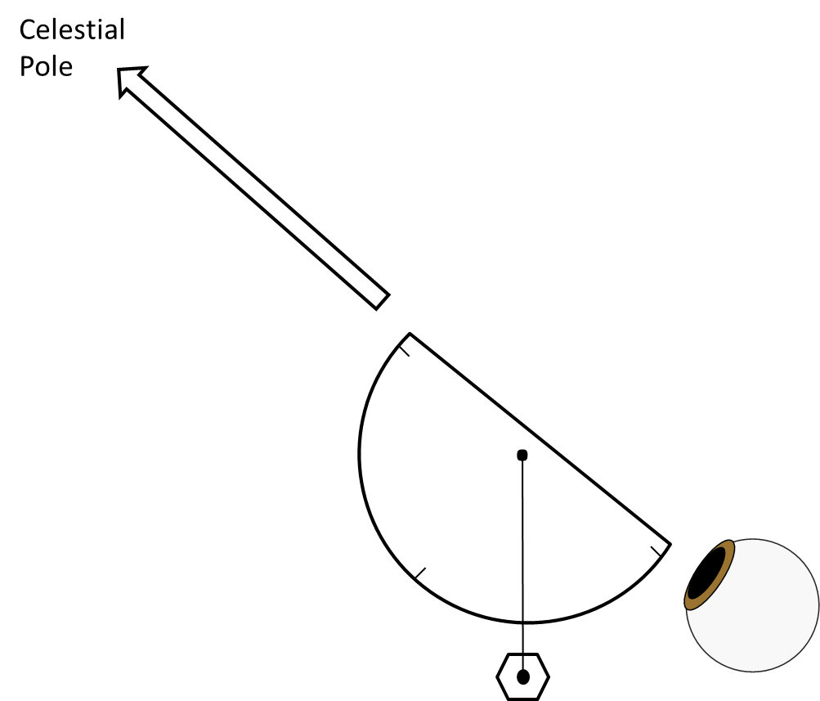

Fig. 1. The addition of a weighted thread to the measuring center of a protractor makes a simple angle measurement device. By looking along the base of the protractor at the celestial pole, the thread indicates the observer’s latitude. (Note that the indicated value may have to be subtracted from 90° to represent latitude, depending on the protractor’s design. Remember that making the protractor’s flat side horizontal is the equivalent of being at the equator where the latitude is 0° and most protractors will read 90°.)

PROCEDURE:

For a measurement of Earth’s circumference, same-day local solar noon measurements of the length of the gnomon’s shadow must be made at two locations with a difference in latitude. A greater latitude difference will improve the accuracy and precision of the final result.

Establish the gnomon, in place and vertical. Measure the height of the gnomon.

Determine the clock time of local noon if a sun dial is not being used. This can be accomplished mathematically with GPS or map coordinates and the formulas in THE UNDERLYING PRINCIPLES or by observation.

To do this by observation, in advance of the coordinated observation date calibrate the gnomon by observing the clock time when the gnomon’s shadow is shortest. Observe the gnomon’s shadow for a span of about two hours, marking the ground every 10 minutes, to confirm the clock time when its shadow is shortest. When daylight saving time is in use, the time of local noon can be over an hour later than clock-noon. (Note: The standard, clock time of noon changes significantly over monthly intervals due to the shape of Earth’s orbit around the Sun).

Confirm the date when shadow measurements will be made with the partnering school. The partner school will need to have made the same preparations as described for your school.

At local noon, measure the length of the shadow of the gnomon.

Now the calculations begin. The length of the shadow and the height of the gnomon form two sides of a right triangle. The angle at the top, ψ (psi), between the hypotenuse and the gnomon, is the one of interest (Figure 2).

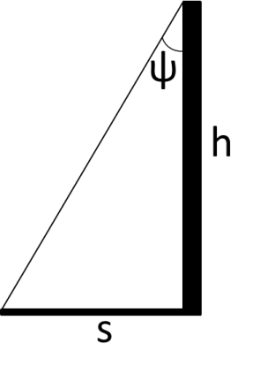

Fig. 2. The tangent of angle ψ is, by definition, the (opposite side)/(adjacent side) = (shadow’s length)/(gnomon’s height):
tan ψ = s/h.

Using the inverse tangent function, calculate ψ.

ψ = arctan (s/h) (1)

Determine the absolute value of the difference in the angles ψ₁ & ψ₂ for the two schools,

Δψ = |ψ₁ – ψ₂| (2)

which is the difference in latitude between the two schools.

The fraction of the circumference (F) of Earth spanned by the two schools is

F = Δψ/360 (3)

If the schools are directly north/south of each other, the distance (D) between them (in kilometers or miles) multiplied by 1/F gives the circumference of Earth (C).

C = D/F (4)

Finding Earth’s radius (R) is easily accomplished by dividing the circumference (C) by 2π:

R = C/2π (5)

THE UNDERLYING PRINCIPLES:

Eratosthenes may have been inspired by the fact that on the summer solstice in Egypt, a viewer’s shadow obscured the reflection of the Sun going down a well at local noon. There on the Tropic of Cancer, a gnomon would exhibit no shadow while further north in Alexandria a measurement of the shadow would give the difference in latitude between Aswan and Alexandria immediately. It would then be easy to make the calculation of Earth’s circumference, even without knowing the actual latitudes of the two cities.

In reality, any pair of known latitudes can be used directly with equations (2)-(5) to calculate Earth’s circumference and radius.

Determining Local Solar Time without a sun dial:

Standard time zones are defined every 15° of longitude, counted from the Prime Meridian at 0° that runs through Greenwich, England. They span 7.5° both east and west of the zone meridian. Determine the difference between your longitude (use GPS or a map) and the nearest time zone longitude (a multiple of 15°). Then calculate the difference between Standard Time and Local Solar Time, LSoT (and sometimes Daylight Saving Time [called Summer Time in some places] must also be included in the calculation).

ΔLong = TZlong - long

The longitude difference turns into time with the conversion 1° = 4 minutes (confirmation: 360° x [4 minutes/1°] = 1440 minutes. 1440 minutes/[60 minutes/1 hour] = 24 hours).

Δt = ΔLong x 4 [min]

ST = Δt + LSoT

Where:
ΔLong = Difference of the longitude of the standard time zone and the gnomon’s longitude
TZlong = time zone longitude
long = gnomon longitude
Δt = Difference from Standard Time
LSoT = Local Solar Time
ST = Standard Time

Example 1: You plan to measure the Sun’s altitude at noon (12:00) Local Solar Time in February. Your gnomon’s longitude is 78°34’ west = -78.5667° so your time zone longitude is -75°.

ΔLong = -75°-(-78.5667°) = +3.5667°

Δt = +3.5667 x 4 = +14.2667 [min]

ST = 12.2667 [min] + 15:00 = 12:14.2667 = 12:14:16 local Standard Time. This is the Standard Time at which a sun dial will show 12:00 noon at this site.

Example 2: You plan to measure the Sun’s altitude at noon (12:00) Local Solar Time in May. Your gnomon’s longitude is 82°36’ west = -82.60° so your zone longitude is -90°.

ΔLong = -90°-(-82.60°) = -7.40°

Δt = -7.40 x 4 = -29.60 [min]

ST = -29.60 [min] + 12:00 = 11:30.40 = 11:30:24 local Standard Time. This is the Standard Time at which a sun dial will show noon at this site. But Daylight Saving Time is in effect: “Spring forward, Fall back.” Add one hour to the Standard Time: The sun dial will show noon at 11:30:24 on the clock.

DISCUSSION:

Noon measurements are required to separate mixing of components of shadow length that would occur at other times of day. Because of the Sun’s apparent annual motion around the sky (a reflection of Earth’s orbital motion), shadow measurements need to be made the same day. At some times of year there can be measurable changes in shadow length from one noon to the next.

Greater latitudinal separation reduces the effects of measurement errors, be they due to the soft shadow edge or uncertainties in the physical distance between measurement sites.

EXTENSION:

Latitude may be determined with a night time observation of the celestial pole (Polaris in the northern hemisphere, Sigma Octantis in the southern hemisphere) using an assembly including a protractor, thread or fishing line, and a spare hexagonal nut or a few paperclips serving as a plumb bob on the thread (Figure 1).

The observer looks along the flat edge of the protractor towards a pole star. Once the plumb bob has settled, a companion with a flashlight can read the angle or a thumb and finger can trap the thread in place and the angle can be read indoors. Common protractor designs will require the observer to subtract the measured angle from 90° to give the observer’s latitude. Combined with another observer’s latitude, the calculation follows equations (2)-(5) as above.

The pole stars in both hemispheres are not exactly centered on their respective celestial poles (Polaris is about 1° off, faint Sigma Octantis is a little closer). This will throw off the results. An advantage of using star observations, though, is that the longitude of the observer plays no roll.

DATA SOURCES:

http://www.mytopo.com/ presents topographic maps of the United States. Pick a location (your city’s name and state) and search for it. Zoom in until your school is visible. Center and then enlarge it further and move the cursor to the position of your gnomon and read its latitude and longitude just outside the lower left corner of the map.

A similar, slightly clumsier procedure can be followed at http://www.noaa.gov/. Search by city and state and then scroll down on the page to the map on the right side. Demagnify, if necessary, and drag the map area around to find your school site, enlarge it, and then click on the gnomon position to specify the “Requested Location.” A less precise position with elevation appears above the map, specified as the area of the “Point Forecast,” with the “Forecast Area” in a green quadrilateral.

ACKNOWLEDGMENT:

This publication was prepared by the Jet Propulsion Laboratory, California Institute of Technology, under a contract with the National Aeronautics and Space Administration.

Reference herein to any specific commercial product, process, or service by trade name, trademark, manufacturer, or otherwise, does not constitute or imply its endorsement by the United States Government or the Jet Propulsion Laboratory, California Institute of Technology.

The zenith is the point in the sky directly overhead. Most people assume it is lower in the sky than it actually is. Looking up, slowly spin your body in place: the axis of rotation of the sky marks the zenith.
The summer solstice marks the maximum points above and below the equator in the Sun’s annual journey through the sky. Summer is defined to begin in the northern and southern hemispheres, respectively, when it reaches those maximum points.
Local noon is measured with a sun dial, not a clock face. Given a school’s longitude, the clock time of local noon is easily computed or it can be determined by observation.
Political time zones on maps usually have much less regular boundaries and spans.
Many GPS units can be set up to provide a good value of longitude (and latitude) right on their screens. Smart phone apps are available for reading longitude and latitude from the phone’s built in GPS receiver. Alternatively, paper maps can be measured and read. On-line maps, like those at http://www.mytopo.com/ and at http://www.noaa.gov/ can be used; see DATA SOURCES for instructions.
It is very easy to get snagged by this calculation. Longitudes WEST of Greenwich are NEGATIVE and subtractions of negative values may occur. The examples illustrate some variations.

