**Document ID**: 06_09_05_1

**Date Received**: **Date Revised**: 2005-10-21 **Date Accepted**: 2005-10-24

**Curriculum Topic Benchmarks**: M4.4.2, M4.4.6, M5.4.4, M5.4.16, S12.4.3

**Grade Level**: [10-12] High School

**Subject Keywords**: planet, planet search, planet mass, planet transit, Doppler Effect

**Rating**: Advanced

# What the Doppler Effect Tells Us

# About Distant Stars & Planets

**By**: Stephen J Edberg, Jet Propulsion Laboratory, California Institute of Technology, 4800 Oak Grove Drive, M/S 301-486, Pasadena CA 91011

e-mail: Stephen.J.Edberg@jpl.nasa.gov

**From**: The PUMAS Collection http://pumas.jpl.nasa.gov

©2005, Jet Propulsion Laboratory, California Institute of Technology. ALL RIGHTS RESERVED.

**BACKGROUND:** Police officers, air traffic controllers, and astronomers all use the Doppler Effect to determine the speed of an object as it approaches or recedes from their radars or telescopes. The frequency (or pitch, for sound) of waves coming from a moving object is changed an amount directly proportional to the speed of approach or recession. The effect of the change, to raise or lower the frequency, specifically indicates that the source is approaching or receding, respectively.

What is now known as the Doppler Effect was first explained by Christian Doppler in 1842, though Armand-Hippolyte-Louis Fizeau and Ernst Mach both developed explanations independently over the next two decades. (In France, in fact, it is known as the Doppler-Fizeau effect.) Since at least the 1860s, astronomers have been measuring the Doppler Effect on starlight to determine stars’ line-of-sight speeds. Stellar velocities across the line of sight are calculated from the observed change in stellar position over time, called proper motion, combined with the star’s distance from us (see the *PUMAS* example “When a Ruler is Too Short,” PUMA Example 04_28_05_1). Combining the line-of-sight speed with the speed calculated across the line of sight generates the velocity of a star in space (called the “space velocity” by astronomers).

In 1991, planets were discovered to be orbiting the pulsar PSR 1257; tiny, repetitive changes in the timing of the pulses coming from the pulsar indicate that four planets are in orbit around it. The Doppler Effect made the pulsar’s period changes apparent. Four years later, precision measurements at optical wavelengths (accurate to a few meters/second, which are much more difficult to do than at radio wavelengths) demonstrated planets orbiting Sun-like stars.

**OBJECTIVE:** Experience the Doppler Effect for sound, first hand. Demonstrate the cosine effect on the Doppler shift as the plane of a source’s orbit changes with respect to the line of sight. Students can compute the frequency change for motion along the line of sight (LOS) and determine the vector LOS component for motions not exactly on it.

Underlying principles are explained in Appendix 1. Extensions to this lesson are found in Appendix 2.

**APPARATUS** (Figure 1, below)**:**

(1) **12VDC piezo buzzer** (e.g., Radio Shack no. 273-059, about $5)connected to a **9V battery.** If you know how to solder, also purchase 9V battery connectors (about $2 for five) and solder the buzzer leads to the battery connector leads, red to red and black to black. This makes turning the buzzer on/off very easy and quick. Otherwise, simply connect the buzzer’s red lead to the + contact on the battery and the black lead to the – (minus) contact on the battery. Note the frequency of the buzzer on the packaging. Beware that the sound can be quite irritating. Keep demonstrations short.

1. **Approximately 30” of strong string or shoe lace.** Use a package knot (ask a boy scout) to securely hold the battery+buzzer combination on one end of the string. If an **insulated twist-tie** is used to hold the buzzer on the battery, a secure knot on a section of the twist-tie opposite the battery terminals should be adequate. Put knots every few inches down the string, and a finger loop in the other end of the string, for a better grip at a variety of swing or “orbit” radii. (A **free-spinning bicycle wheel** with the buzzer+battery **duct**-**tape**d to the spokes or rim is more controllable and repeatable for experiments. An **electric hand drill** with a **cylindrical sanding drum** attachment can be used to spin-up the wheel.)
2. **Cheap rubber ball.** Use a sharp knife to hollow out a volume near the center of a soft, solid rubber ball, about 3” in diameter (available from toy stores, about $1). The hole should be large enough to jam the battery+buzzer (with string attached) into the ball, but with a tight-enough fit that friction between the battery+buzzer and the ball’s remaining interior will hold the ball on the sound source when it is swung in circles with the string. Make an additional tunnel, if necessary, so sound from the buzzer escapes the ball instead of being absorbed by the rubber.
3. **A watch with second hand or a stop watch.** This can be used to determine the speed of the buzzer, if desired.

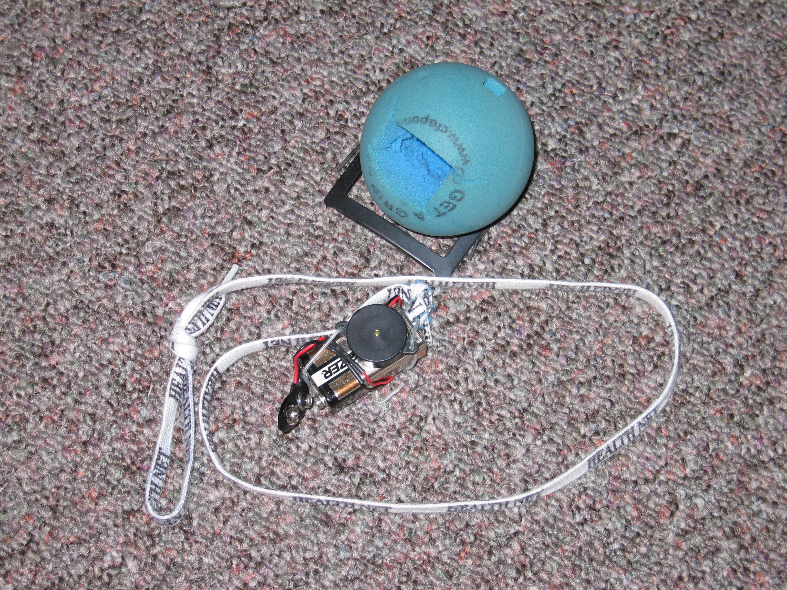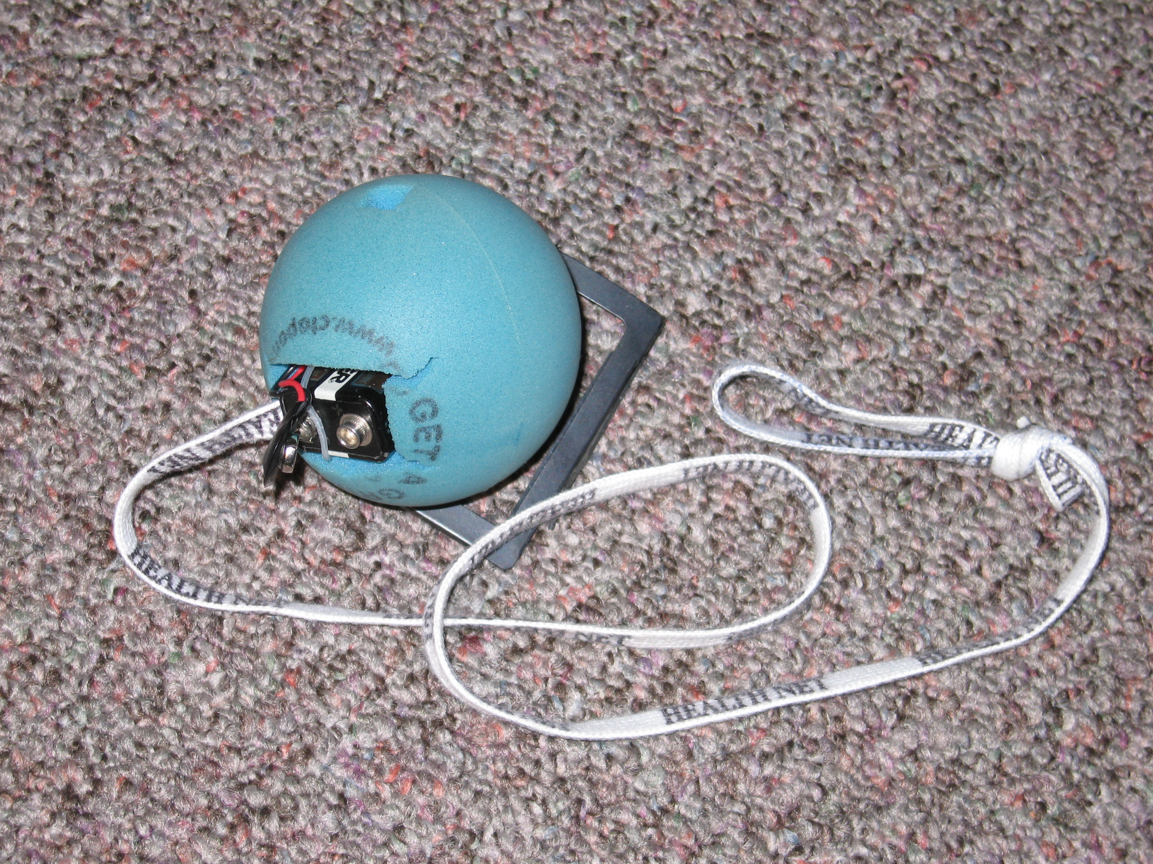

Figure 1. The piezo buzzer is attached to the 9V battery with a long, insulated wire twist-tie through its holes and around the battery. A battery connector was soldered to the buzzer leads. The shoe string is attached to the twist-tie, at the end opposite the battery terminals. The whole assembly is jammed into the ball, with the buzzer facing the small hole that lets its sound escape (near the top of the ball in the pictures).

**PROCEDURE:** Introduce the Doppler Effect for sound by citing familiar examples: a train or automobile horn blowing as it passes an observer. Note that most people do not distinguish between the change in volume (amplitude) of the horn and its apparent change in frequency (pitch). Demonstrate the distinction by swinging the buzzer in horizontal circles with the attached string. Point out that the difference in distance due to the buzzer’s “orbit” is much less than the distance from your hand (the orbit’s center) to the listeners in the classroom. The variations the students are hearing are due to the Doppler Effect rather than volume changes.

(**Tangential Discussion:** This can be demonstrated with a calculation based on the inverse square law: Measure the distance between the buzzer’s orbit’s center and (1) the nearest student in the room and (2) the farthest student in the room. For each student calculate the signal strength ratio

(distance + [orbital radius])2/(distance - [orbital radius])2 (1),

the ratio of the signal strength, farther/nearer, from the buzzer when it is at either end of its orbit with respect to the nearest and farthest students. The result, especially for the more distant student, will be that the signal strength ratio is quite small, implying that the variation heard by the students is not related to amplitude (sound volume) changes but is the result of the Doppler Effect.)

If your buzzer is encased in a soft rubber ball, gently toss the ball to different students around the room, encouraging everyone to listen with each throw from you or back to you. The amplitude change is apparent but the Doppler shift can be quite noticeable as the ball goes by students along the line of flight. Those off the line may notice a much-diminished effect, which is the point of this lesson.

Resume the demonstration by orbiting the buzzer horizontally again. With a vertical orbit plane, have the buzzer make several revolutions in one orientation with respect to a nearby wall. Change the plane of the orbit with respect to the wall and make several revolutions. Repeat this several more times so students hear the differences that being in the plane or varying degrees out of the plane of the orbit make.

**ACKNOWLEDGMENT:** This publication was prepared by the Jet Propulsion Laboratory, California Institute of Technology, under a contract with the National Aeronautics and Space Administration.

Reference herein to any specific commercial product, process, or service by trade name, trademark, manufacturer, or otherwise, does not constitute or imply its endorsement by the United States Government or the Jet Propulsion Laboratory, California Institute of Technology.

**Appendix 1**

**THE UNDERLYING PRINCIPLES:** The frequency (pitch) heard by a stationary observer is given by the equation

ν' = ν0 x (c)/(c + vs) (2a)

where ν' = the shifted frequency,

ν0 = the frequency of the source when it is stationary,

c = the speed of the wave, and

vs = the speed of the source along the line of sight

The choice of + or – is made so the frequency is lower for a receding source (a “red” shift), i.e., use the + sign. Use the – sign for an approaching source, since the frequency is higher (a “blue” shift).

The Doppler Effect also manifests itself if the source is stationary and the observer is moving. In that situation, the equation reads

ν' = ν0 x (c + vm)/c (2b)

where vm = the speed of the observer and same sign convention applies: for recession (a red shift) use the – sign; for approach (a blue shift) use the + sign.

Equations 2 assume that the motion is in the line of sight. If that is not the case, the change in frequency is a function of the angle between the line of sight and the line of motion. The vector component of velocity in the direction of the observer vobs, is

vobs = vs x cos α (3)

where α = the angle between the direction of motion and the observer. Note that as the observer gets closer to the line of sight, α goes to zero, cos α goes to 1, and therefore the speed of the source, used in equation (2a), reaches its maximum value and so does the Doppler shift. As α goes to 90 degrees, cos α goes to zero, the apparent speed of the source along the line of sight goes to zero, and the Doppler shift goes to zero (Figure 2).

Rotation Axis

Direction of motion, towards or away from the observer

 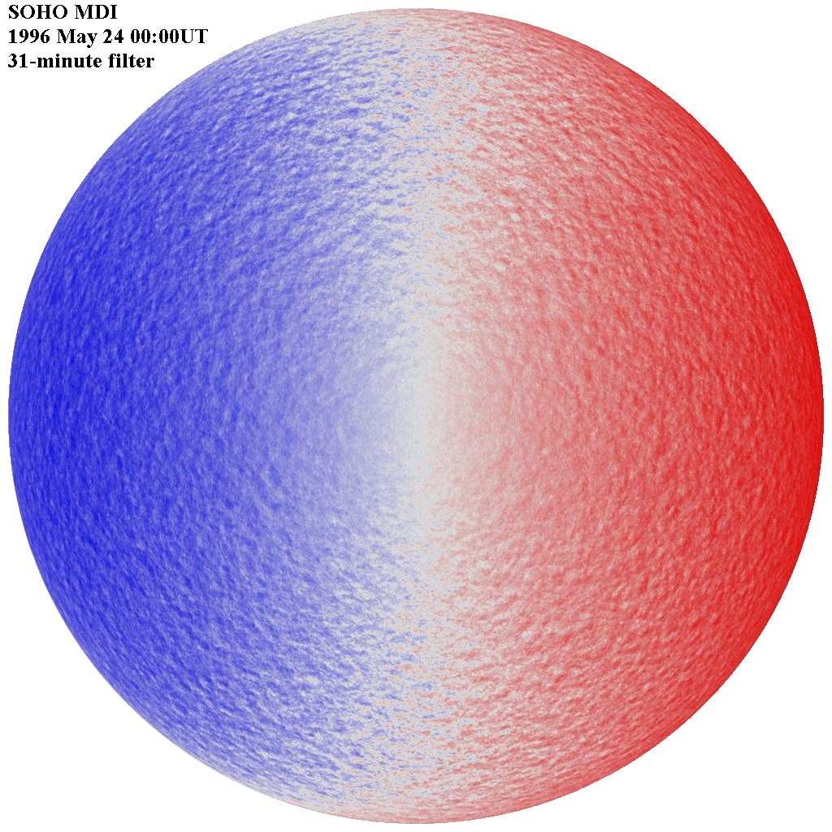

Vector component in the line of sight of the observer, magnitude less than the magnitude in the direction of motion

α

α

Moving Object



-2 km/s

α=90°

Towards

+2 km/s

α=90°

Away

0

α=0°

(b)

SOHO (ESA & NASA)

(a)

Figure 2. (a) The geometry for the Doppler shift of a moving source. As angle α reaches 0°, the maximum Doppler shift will be observed because the observer is in the line of motion. As angle α reaches 90°, all motion is across the line of sight and the Doppler shift is zero.

(b) This Dopplergram of the Sun, in false color, illustrates the intensity of the blue and red shifts due to solar rotation. The spherical shape of the Sun provides the change in angle α. Note how the shift zeroes out along the central meridian, where all motion is across the line of sight. The mottled appearance is due to smaller, independent motions of gases in the solar photosphere. (Motion of the Sun, or a star, about the center of mass of its system of planets, is not illustrated here and would not have this appearance.)

Planets orbiting other stars are detected by the periodic Doppler shift observed in the motion of the parent star (caused by its orbit about the center of mass of the star-planet system). When the normal to the plane of a planetary orbit is not known, the speed of the planet carries a factor of cos α. The mass of the planet can be inferred from the parent star’s orbit and if angle α is close to zero, the result will be close to correct. But if the system is being observed nearly perpendicular to the plane of the orbit, a large planetary mass is required to cause the observed Doppler shift. So if α is unknown, we can infer only a minimum mass for the planet.

To quantify the observed Doppler effect, you need the speed of the buzzer, which can be determined as follows:

A. The radius, r, of the orbit, from the pivot at the finger-center or knot to the buzzer output must be measured. Count the number of revolutions, n, in a convenient (10 - 60 second) period. Then the distance traveled is

d = (circumference of the orbit) x (number of revolutions)

= (2πr)n (4)

and the speed of motion is

v = (2πr)n/(measurement period in seconds) [length units/second] (5)

B. Measure the distance L traversed by the buzzer as it is thrown across the room. With a stopwatch, time the flight duration, t. Then the speed of flight is

v = L/t [length units/second] (6)

Note that this speed has much less accuracy, primarily because the duration of flight is short and the reaction time of the stop watch operator (at the release of the throw and at the catch) is going to be a significant fraction of the true duration in most average-size classrooms).

Waves are sometimes described not by their frequency or pitch, but by their wavelength, the distance between peaks or valleys in a wave train. The Doppler Effect stretches (red shift) or compresses (blue shift) the wavelength. Many attributes of waves depend on their wavelengths. Scientists describe waves by their frequency or wavelength depending on which is more convenient for the work they are doing.

For a wave traveling at speed c, there is a simple relationship between wave speed, frequency, and wavelength:

λ = c/ν (7)

where λ = the wavelength of the wave. From this, you would expect that if the frequency of the source goes up (e.g., an approaching object), the wavelength will decrease. (Since the shortest visible wavelengths of light are at the blue end of the spectrum, this is called a “blue shift.”) [One caveat: in some cases, the wave speed itself depends on its frequency.] The most interesting wave speeds for this lesson are the speed of sound, approximately 340 m/s at sea level and the speed of light, 299,792,458 m/s in a vacuum.

**DISCUSSION:** The recognition that the motion of astronomical objects in the line of sight could be measured opened new areas of investigation for astronomers. The motions of stars in the Milky Way could be analyzed and conclusions drawn with appropriate statistical analyses. Perhaps the most famous result based on the use of the Doppler Effect was Edwin P. Hubble’s demonstration that the universe is expanding.

More recently, precision Doppler measurements have been used to detect the reflex motion of a star as the gravity of a planet orbiting it forces the star to orbit their mutual center of mass. The velocities involved are only a few meters per second. To be seen these measurements require very high precision. The analysis of these observations involves not simply measuring a Doppler shift relative to a stationary source at the telescope. The orbital and rotational motion, among others, of Earth, and the direction of the star with respect to the plane of Earth’s orbit must be accounted for (using equation (2b) and the cosines of the angles involved).

Face-on Circular Orbits

(a) Tilted Circular Orbits

Figure 3. (a) The orbits of a planet (solid curve) and its parent star (dashed curve) around the system center of mass are illustrated here. Both objects revolve around the center of mass of the system. The maximum Doppler shift occurs at the ansae of the tilted system (at the arrows), with the effect at a maximum if the tilt places the orbital plane exactly in the observer’s line of sight. There is no Doppler shift if the observer is normal to the plane of the orbits, viewing them face on (illustrated on the right). Planetary searches observe the Doppler Effect on light from the parent star as it moves about the system’s center of mass. The illustrations are schematic, with the star’s and planet’s sizes and the star’s motion greatly exaggerated.

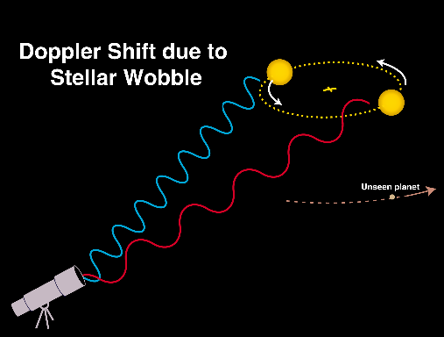

*Planet Position for Maximum Blue Shift*

*Planet Position for Maximum Red Shift*

Figure 3. (b) The Doppler shift of a star’s light depends on where in *its* orbit around the star-planet center of mass it is. Two extreme positions of the star are shown, where the shift is maximum. The unseen planet is illustrated in positions when the star’s maximum Doppler shift is exhibited and it would be on the line extending from the star through the center of mass of the system. This illustration is schematic and not to scale in any sense.

The interpretation of these results must be couched in an important qualifier: the mass of the inferred planet is always a lower limit unless the tilt of the orbital plane is known. Such knowledge is rare: only a few stars’ planets transit the parent star, telling us that we are in the plane of the planet’s orbit and therefore the cosine of the tilt angle, 0 degrees, is 1.

**Appendix 2**

**EXTENSION:** A much more elaborate demonstration can use either (1) a microphone, amplifier, and oscilloscope to capture and present the wave form of the sound from the buzzer and its changes in amplitude and wavelength due to the Doppler shift or, with greater flexibility, (2) a microphone+software combination (available from several vendors) that allows data to be acquired, recorded, and plotted under computer control, capturing the same effects. Computerized data acquisition is common on spacecraft and in laboratories and observatories on Earth.

Repeat the orbiting buzzer and thrown buzzer experiments with the microphone in the plane of the orbit, out of the plane of the orbit, along the line of flight, and well off of the line of flight. If you can control the orbital speed of the buzzer well enough, the calculation of the shifted frequencies can be directly checked against the measured maximum and minimum frequencies captured by the microphone. (Check the frequency of the stationary buzzer in the course of your measurements.) Variations in the amplitude of the buzzer signal, due to the changing distance between buzzer and microphone, can be used to determine the rotation rate if the data are collected with a time signal (common with software data acquisition systems).

If you can control the plane of the orbit well enough (using a bicycle wheel makes this much easier), measure the angle of the normal to the plane to the normal of the wall for each set of wave form data. The angle data can be used in the analysis of the wave forms to compare the effect of in-plane vs. out-of-plane Doppler shifts. Be aware that echoes from the walls may confuse the results.

The wave form data alone, specifically the wavelength and amplitude at selected times/positions, will nicely demonstrate what the students are hearing.

**FOR MORE INFORMATION:** Visit this website for more information on extra-solar planets: <http://planetquest1.jpl.nasa.gov/atlas/atlas_index.cfm>