Document ID: 08_19_05_1
Date Received: 2005-08-19 Date Revised: Date Accepted:
Curriculum Topic Benchmarks: M3.4.1, M3.4.5, S13.4.6, S14.4.1, S14.4.2
Grade Level: [9-12] High School
Subject Keywords: gravitation, force, Moon, Sun, Earth, tides, inverse square law
Rating:

The Moon Orbits the Sun?!?!

By: Stephen J. Edberg, Jet Propulsion Laboratory, California Institute of Technology, 4800 Oak Grove Drive, M/S 301-486, Pasadena CA 91011
e-mail: Stephen.J.Edberg@jpl.nasa.gov

From: The PUMAS Collection http://pumas.jpl.nasa.gov
©2005, Jet Propulsion Laboratory, California Institute of Technology. ALL RIGHTS RESERVED.

Even the most casual observers note the changes in the phase of the Moon as it goes from crescent to half to full and back again with a “monthly” cycle. (See Glenn Simonelli’s PUMAS submission “Modeling the motions of the Earth, Sun and Moon” [http://pumas/PDF_Examples/03_10_04_1.pdf].) Their observations, or what is “common knowledge”, lead them to believe the Moon does loops around the Earth. But is this true? A comparison of the gravitational forces of the Sun and Earth on the Moon hints at the answer to this question and a simple demonstration refutes the loop-view.

OBJECTIVE: Compute the strengths of the gravitational forces exerted on the Moon by the Sun and by the Earth and compare them. Demonstrate the actual shape of the Moon’s orbit around the Sun. Understand the difference between gravitational forces between bodies and tidal forces generated by those bodies and compare the two.

APPARATUS: This teaching aid demonstrates the actual shape of the lunar orbit as it plays out over a year or a portion of a year. Two parts are necessary: (1) a large circular cut-out or a large circular disk, or circumferential sections of each (because of the required sizes) and (2) a small disk, both parts made to the appropriate scale (discussed below).

The demonstrator is built to be a scale model of the Sun-Earth-Moon system. For a durable device, go to a hardware store for thin wood veneer, plywood, or a Plexiglas®-like material, 1/16 to 1/4 inch thick. These materials require a wood or metal saw and sand paper for cutting, shaping, and smoothing.

A large piece of cardboard or dry mounting board can also be used. These materials require sharp blades and sand paper for cutting, shaping, and smoothing. Other large circular products, such as disposable serving trays and plastic pots for plants are also suitable if the necessary sizes can be found.

Use a string or rope fixed to a pivot on one end and to a pen or awl on the other end to serve as a compass to create the large radius for the Earth orbit disk.

A drill is necessary for making a hole in the small disk.

This demonstrator works much like a Spirograph® but the final pattern will be much simpler than what a Spirograph® can produce. A large circular cut-out or a large disk represent Earth’s orbit and a small disk carries the Moon’s orbit around Earth. The biggest problem in construction is the difference in size between the radius of the Moon’s orbit and the radius of Earth’s orbit, which is 391 times larger (a discussion of the actual, elliptical shapes of their orbits is in Extension (2), below). Note that the sizes of the large cut-out/disk and small disk will not be in exactly the orbital ratio.

Choose a size so your writing implement (pen, white board pen, or chalk; pencil is not recommended) will fit through a hole in the lunar orbit disk and can trace out the Moon’s path. A very fine point pen’s tip (representing the Moon) 2 mm from the center of the lunar orbit disk requires Earth’s orbit to be 782 mm in radius. A larger pen or chalk will have to be more separated from the center of the lunar orbit disk and the Earth orbit cut-out/disk will have to be proportionally larger.

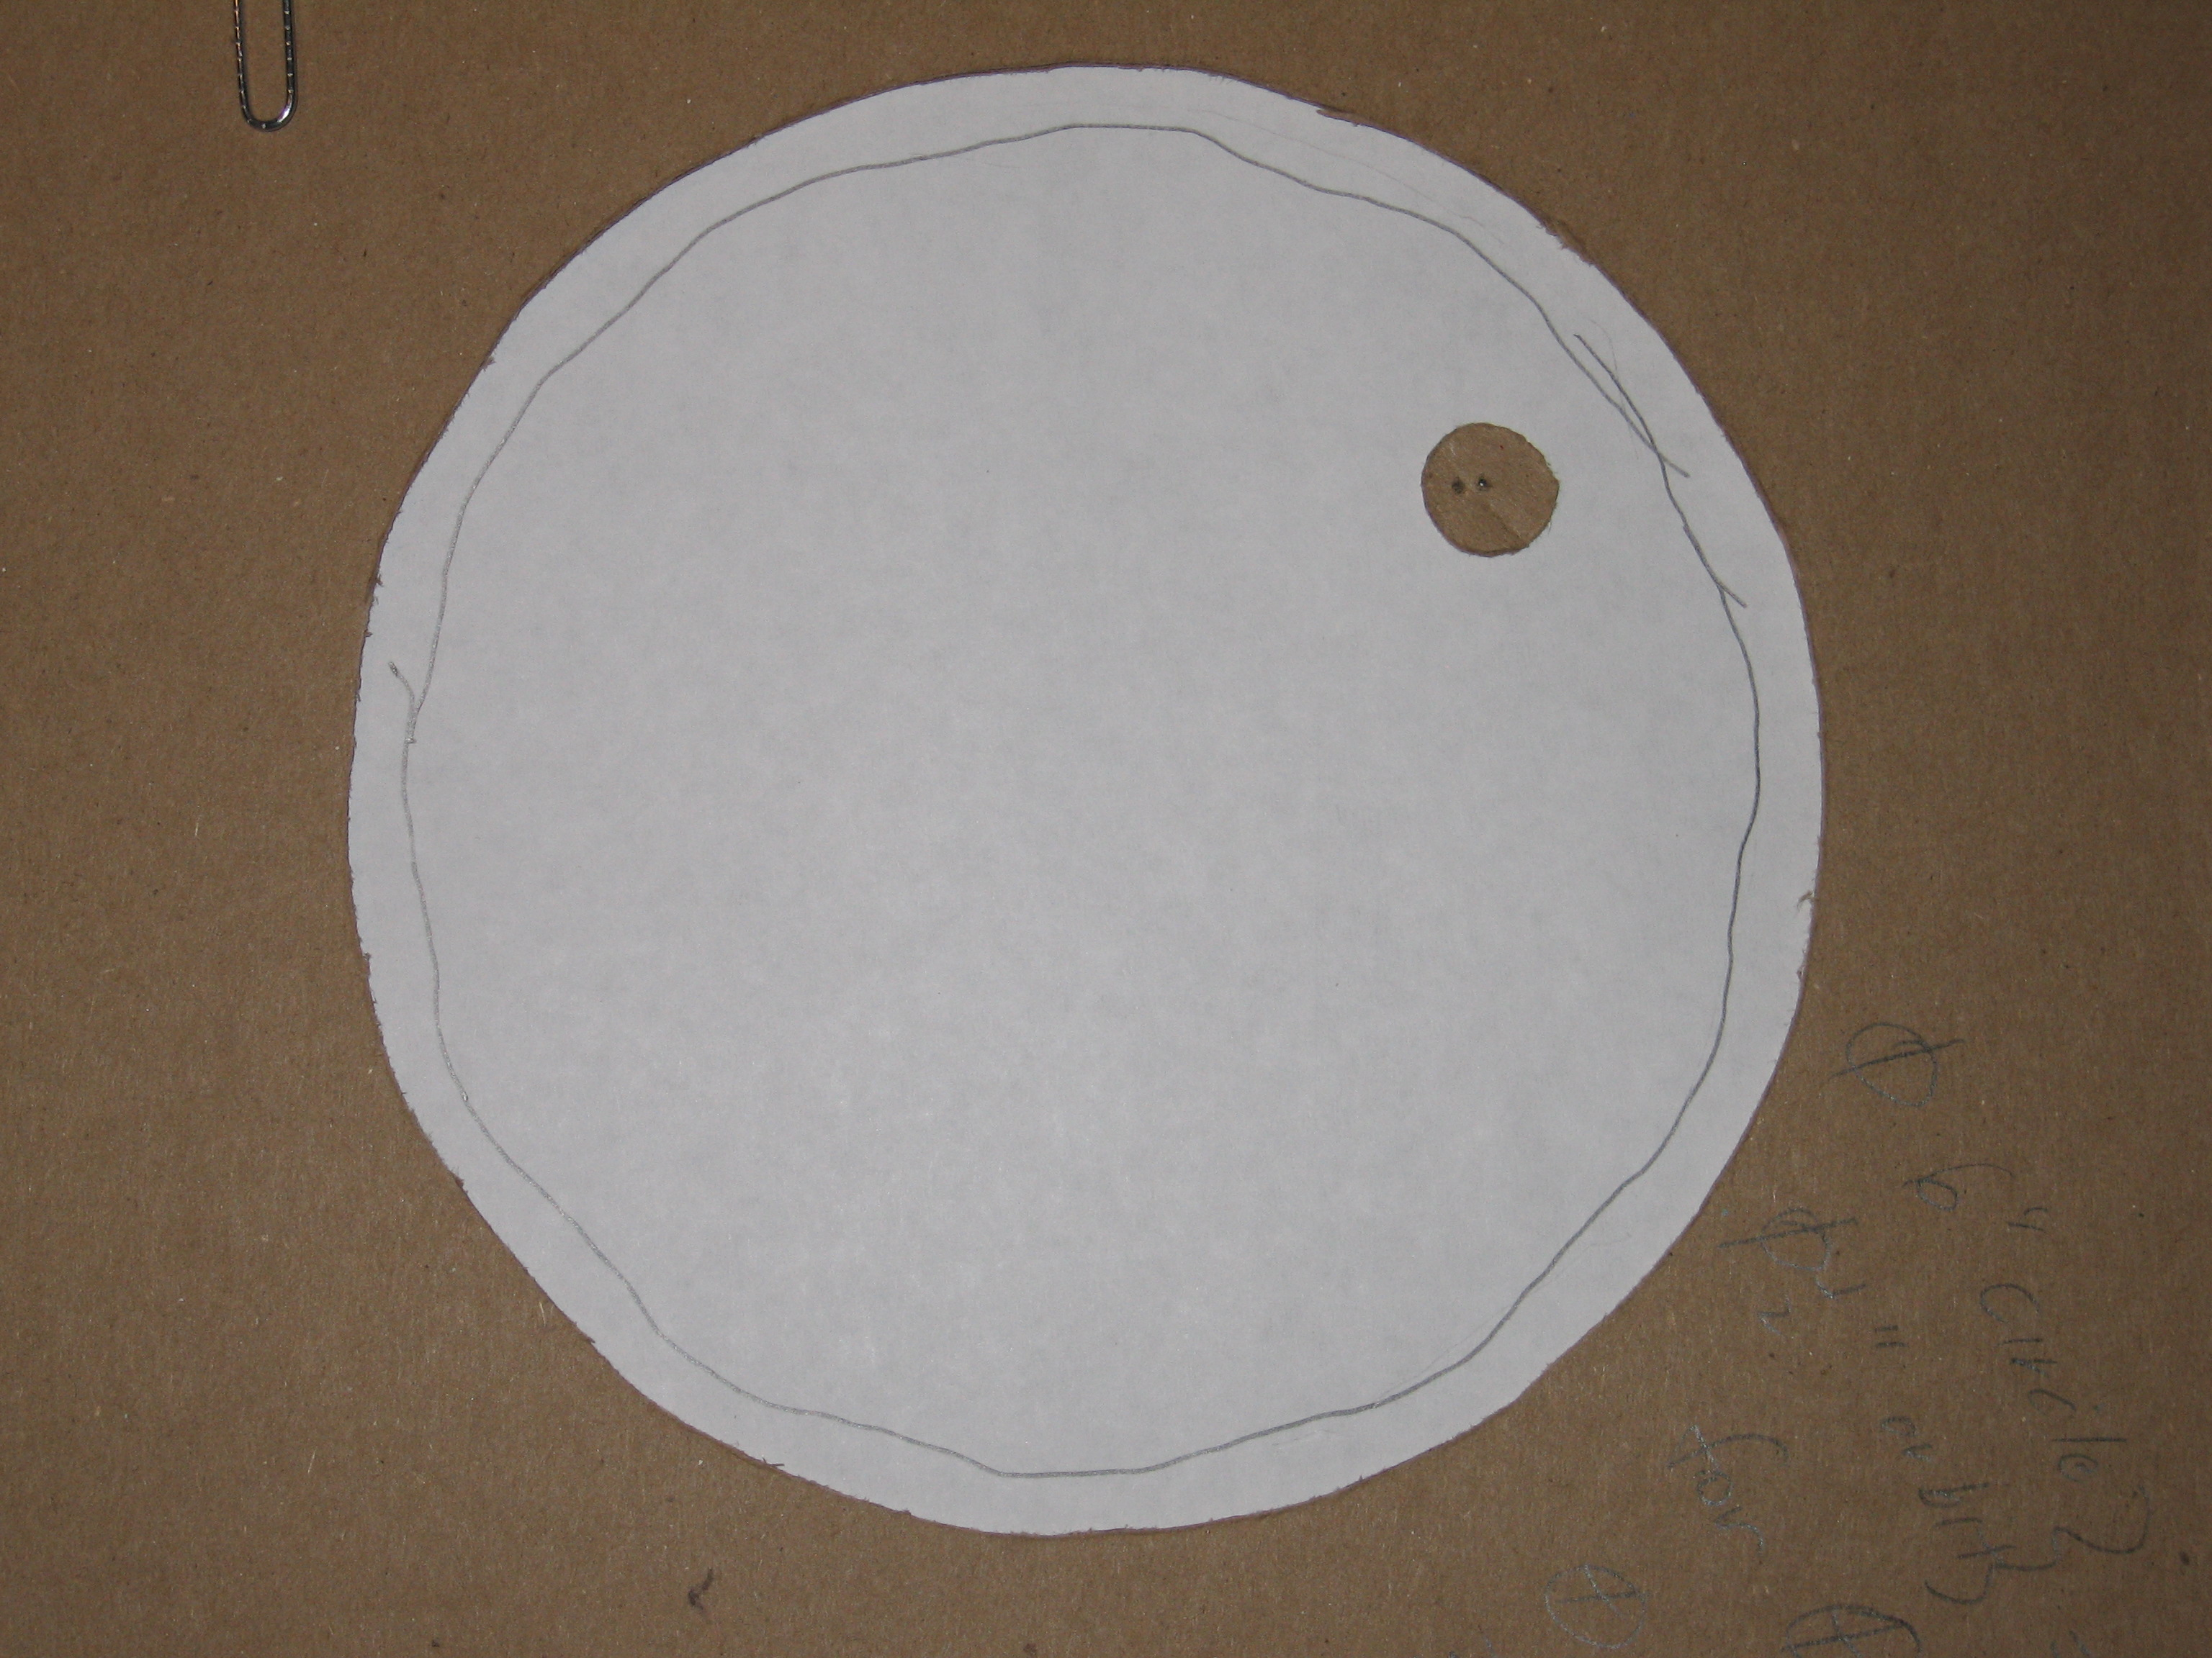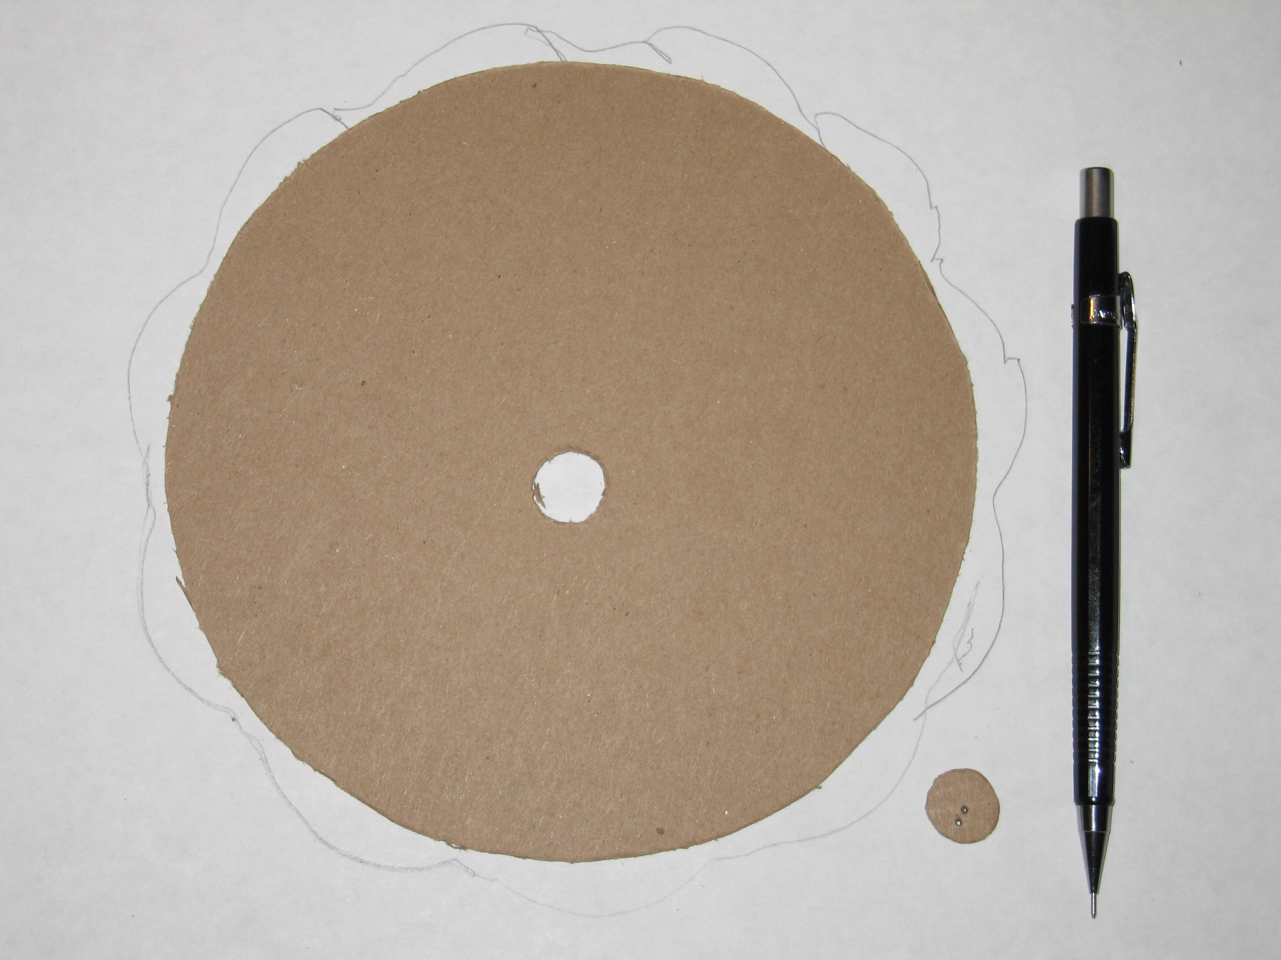
(a)
(b)

Figure 1. Two construction methods and use of the orbit demonstrator. These cardboard prototypes were not made to scale.
(a) This is the “cut-out” design. The large cut-out circle is centered on the “Sun”. The small disk, with “Earth” at its center, has a small hole for a pencil tip, representing the Moon, with an offset from “Earth.” With a pencil or pen tip in the “Moon” hole, this lunar orbit disk will trace out the Moon’s path around the Sun as the disk rolls around the inside of the cut-out.
(b) This is the “disk” design. The small disk rolls around the outside of the larger disk. The small disk again represents the lunar orbit, and was cut from near the center of the larger disk; the remaining hole can also represent the Sun. Irregularities in the orbital paths can result from poor shaping of the parts and slippage of the small disk as it rolls. Better materials and more careful construction will minimize these problems.

Note in Figure 1 that the cut-out design (a) forces the apparent lunar revolution to be in the direction opposite of Earth’s orbital motion. The result is the same but esthetically the presentation is not as satisfying as the disk design (b), which permits both orbital motions to be in the same direction, as they are in the solar system. However, the cut-out design may be easier to use, especially on a big-enough white- or chalk-board because its base can sit in the pen or chalk tray. A disk segment will have the same advantage.

Alternatively, the disk design can be built using a large commercially available product like a disposable serving tray or plant pot and a smaller disk or cylinder, such as a medicine bottle, thread spool, or other disk or cylinder of material that can be easily “worked”. However, only one disk’s radius is a free variable; the other must be built to conform to the chosen disk’s size since the ratio of the Moon’s orbital period and Earth’s orbital period are involved in the sizing of their orbit disks (or Earth orbit’s cut-out).

Specifically, the ratio of the circumference of the lunar orbit to Earth’s orbit must match the ratio of their orbital periods (with respect to the Sun):

(lunar orbital period)/(Earth orbital period) = 29.5306 days/365.2425 days

Maintaining this ratio preserves the true orbital geometry and timing (lunar revolutions per year) of the Sun-Earth-Moon system.

Make calculations as illustrated in the tables below. In all cases, the free variable is in the left-most column. In the other columns, the variable name and the formula for calculating it are given at the top. A spreadsheet is easily constructed to permit the selection of suitable design parameters. (In the Microsoft Word version of this lesson, double clicking on the desired table should bring up a working spreadsheet.)

The radius of Earth’s orbit, R_{E}, for the demonstrator is the difference or sum of the radii of the Earth orbit cut-out or disk, respectively, R_{ED}, and lunar orbit disk/cylinder, R_{LD}. The lunar orbit radius, R_{L}, is 1/391 of the radius of the Earth’s orbit. This orbital ratio forces the demonstrator to be large if the wavy trace of the lunar orbit is to be distinguishable, say, a few millimeters at least. The examples in Tables 1c and 1d are impractical. Also, if Extension topic (4) discussing the concavity of the lunar orbit is going to be used, the trace of the lunar orbit should be recorded over a span of at least 1/12 of the circumference (2πR_{E}) of Earth’s orbit.

Demonstrator Calculations
Tables 1a
Choose Lunar Orbit Radius

Tables 1b
Choose Lunar Orbit Disk/Cylinder Radius

Table 1c
Choose Earth Orbit Disk Radius

Table 1d
Choose Earth Orbit Cut-Out Radius

Table Notes: The ratio of the radii of Earth’s orbit to the Moon’s orbit = 391. The lunar orbit duration with respect to the Sun (e.g., new moon to new moon, the synodic period) is 29.5306 days. Earth’s average Gregorian year (i.e., with respect to the Sun) is 365.2425 days. Calculated values are presented to 0.01 mm though the best precision possible with a good ruler is approximately 0.33 mm.

PROCEDURE: Discuss with the students their assumptions about the motions of the Moon about the Earth and the Earth about the Sun. After reaching consensus, use the demonstrator.

Install your marker in the lunar orbit disk and roll the lunar orbit disk around the Earth orbit cut-out/disk. If you trace through a whole year (a full revolution of Earth around the cut-out/disk), the lunar path won’t close on itself since there is not an even number of lunar revolutions in a year. Remove the demonstrator parts and study the orbital pattern laid down by the marker – no loops!
Figure 2. The cardboard segment on the left and the circumscribed wood rectangle (holding an off-center pen) at bottom right are correctly scaled for the Earth Orbit Disk and Lunar Orbit Disk, respectively, matching the last line of the first Table 1b. The curved lunar orbit to the right of the segment only appears to parallel the segment edge. In fact, there are variations of almost +5 mm radially from the cardboard curve. The straight line, coincidentally tangent to the cardboard segment, is a chord approximating the separation of the beginning of one lunar orbit to the start of the next, as described in Extension (4). The Moon’s orbit is never convex toward the Sun (to the left in this view).
In constructing the disks, smooth, constant radius curves are required, better than the cardboard cutting shown here.
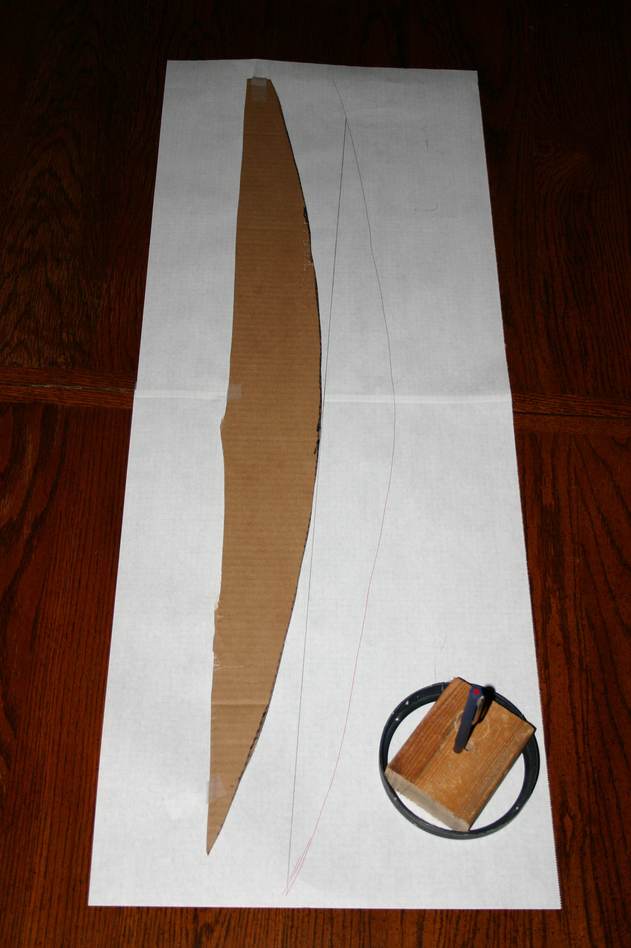

THE UNDERLYING PRINCIPLES: The force of gravity is described by Isaac Newton’s law of gravitation:

F₁₂ = $\frac{G´m1´m2}{R´R}$ (1)

where G is a constant, 6.674x10¹¹ Nm²/kg². In the units of the constant, the abbreviation for the unit of force, called a Newton, is N. One Newton is the force exerted by a mass of 1 kg accelerating at 1 m/ s².

Calculate the forces between Sun-Earth, Sun-Moon, and Earth-Moon using these values:

Table 2
Force Calculation Parameters

 | Mass [kg] | Diameter [m]
Sun | 1.98E+30 | 6.96E+08
Earth | 5.97E+24 | 1.27E+07
Moon | 7.35E+22 | 3.48E+06
 | Distance [m]
Sun-Earth | 1.50E+11
Sun-Moon | 1.50E+11
Earth-Moon | 3.84E+08
Gravitational Constant, G [Nm²/kg²] |  | 6.67E-11
Gravitational Interaction | Combination | Force (N)
 | Sun-Earth | 3.53E+22
 | Sun-Moon | 4.34E+20
 | Earth-Moon | 1.98E+20

Notes on the values in the table: The diameter of the Earth is the mean diameter of the planet, not its equatorial nor its polar diameter. The Sun-Earth distance given is the average distance between Earth and Sun, which is called an Astronomical Unit, or AU. The distance between Earth and Sun varies due to the ellipticity of Earth’s orbit. The Sun-Moon distance is taken to be the same as the Sun-Earth distance, though the Sun-Moon distance varies by ± the Earth-Moon distance. The Earth-Moon distance is an average value since the Moon’s orbit is also elliptical.

Of greatest interest is the difference in the strength of the gravitational force of the Sun and Earth on the Moon: Despite Earth’s proximity to the Moon, the Sun’s force on it is more than twice that of Earth. Thus the force calculation shows that the Sun controls the motion of the Moon; Earth applies a rather strong perturbation to that motion, just as the orbit demonstrator shows.

EXTENSIONS: (1) The strength of the Sun’s gravitational force on Earth is about 178 times stronger than the Moon’s. Is this reflected in tides, which manifest the differential strength of the gravitational force across an object? To find out, calculate the gravitational field on the near side and far side of Earth, near and far being related to the direction to the Sun or to the Moon. The distances to use require a term that is (+) the radius of Earth (6.371E+06 m). Only the mass of the gravitating body (the Sun or Moon, for tides on Earth) is used in the equation.
Tidal Force = $\frac{G×m1}{\left(R−r\right)\left(R−r\right)}\frac{}{}\frac{G×m1}{(R+r)(R+r)}$ (2)
Table 3
Tide Calculation Parameters

Tides | Difference in Gravitational Field at Ends of a Diameter [N/kg]
 | Sun-Earth | 1.01E-06
 | Moon-Earth | 2.20E-06

The tidal effect of the Moon is more than twice the effect of the Sun because the fractional difference in distance between the near and far sides of Earth, with respect to the Moon, is much greater than it is with respect to the Sun. The Sun’s greater mass is not enough to overcome the difference in distance (squared).

The force and tidal calculations can be repeated, if desired, using the perihelion and aphelion values for Earth-Sun (1.471E+11 m and 1.521E+11 m, respectively) and perigee and apogee values for Earth-Moon (3.566E+08 m and 4.066E+08 m, respectively).

(2) For a more realistic presentation of the orbits of Earth and Moon, construct their actual elliptical orbits for use in the orbit demonstrator. Earth’s orbital semi-major axis is 1.496E+11 m and its eccentricity is 0.0167. The Moon’s orbital semi-major axis is 3.84E+08 m and its eccentricity is 0.0554. A loop of string around a fixed pair of nails, placed at the foci of the ellipses, can be stretched with a pen or awl to generate ellipses of the desired sizes.

(3) Do Earth satellites, or can anything else, do loops as Earth orbits the Sun? Create a scenario for students: You are at the North Pole or South Pole (and assume Earth’s axis is not tilted with respect to the plane of Earth’s orbit). Calculate the linear speed of a race car on a 100 m radius track centered on the pole, circling in the direction of Earth’s rotation. Make the same calculation for a medical centrifuge spinning at 6000 rpm and radius 20 cm centered on the pole. Compare those speeds to Earth’s orbital speed ([orbital circumference]/[1 year], in appropriate units). For loops, the linear speed must exceed Earth’s orbital speed. Do the natural satellites orbiting the outer planets do loops?

(4) Is the Moon’s orbit ever convex with respect to the Sun or does it always have a greater or lesser degree of concavity? While drawing the Moon’s orbital path with the orbital demonstrator note the points where the Moon is at its maximum elongation leading or trailing Earth. These are the points of first and last quarter (half moon in the sky). On the lunar orbit curve, use a straight-edge to add some chords between first and last quarters. Compare the distances from the middle of the chord to the nearest point of the orbital path. In all cases, the path is outside the chord, with the shorter distance occurring where the Moon is between the Earth and the Sun (new moon). Since the Moon’s path never crosses the chord, the path is always concave, to a lesser or greater degree, towards the Sun.

Alternatively, calculate the perpendicular distance from the Sun to the chord separating first and last quarters. If the difference |(chord distance)-(Astronomical Unit)| is greater than the maximum separation of Earth and Moon, the path of the Moon must always be concave towards the Sun.

(4) The demonstrator may remind you or students of the Aristotelian model of the solar system as described by Ptolemy to display the observed motions of the planetes (wanderers): Earth at the center of the universe with large circles, called deferents, carrying small circles, called epicycles. The goal of this model was to use the “perfection” of the circle to match the observed motions of the planets by placing the planets on a rotating epicycle, carried by the rotating deferent. The rotation rates of the deferents and epicycles were calculated to match the observed motions of the planets. The apparent “backward” (retrograde) motion of the outer planets Mars, Jupiter, and Saturn around their times of opposition (i.e., when they are aligned Sun-Earth-planet) and the comings and goings of Mercury and Venus in dawn and dusk skies required the inclusion of epicycles in the model. Ultimately epicycles were added to epicycles to try and more closely match the observed motions.

We now know, of course, that the Sun is near the center of mass of the solar system, that gravitational forces control planetary motions, and that elliptical orbits are required to match the observed motions of the planets. The theorems of the calculus indicate that an infinite number of circular epicycles upon epicycles on a deferent would be required to approximate an ellipse. A Ptolemaic demonstrator can be constructed by making appropriate choices of large cut-out/disk and small disk diameters based on the angular span of an outer planet’s retrograde (apparent “backward” motion in the sky) loop (illustrated in many astronomy textbooks and with planetarium software).

REFERENCES and ACKNOWLEDGMENTS: Orbital period, mass, diameter, eccentricity, and distance values used here were taken from the Observer’s Handbook 2005 of the Royal Astronomical Society of Canada, Rajiv Gupta, Editor. Parts of this discussion were inspired by the author’s reading, early in high school, of Isaac Asimov’s essay “Just Mooning Around”, found in his collection Of Time, and Space, and Other Things (Avon, 1975). Glenn Simonelli’s PUMAS submission “Modeling the motions of the Earth, Sun and Moon” (http://pumas/PDF_Examples/03_10_04_1.pdf) was a major motivator in preparing this lesson.

This publication was prepared by the Jet Propulsion Laboratory, California Institute of Technology, under a contract with the National Aeronautics and Space Administration.

Reference herein to any specific commercial product, process, or service by trade name, trademark, manufacturer, or otherwise, does not constitute or imply its endorsement by the United States Government or the Jet Propulsion Laboratory, California Institute of Technology.

