Document ID: 09_21_05_2
Date Received: 2005-09-21 Date Revised: 2006-06-19 Date Accepted: 2006-06-19
Curriculum Topic Benchmarks: S15.4.4, S15.4.5, S15.4.6, S17.4.1, S17.4.2, S17.4.3, M4.4.9 (primarily for Extension activities)
Grade Level: [9-12] High School
Subject Keywords: interferometer, interference fringes, telescope
Rating: Advanced

Seeing Interference Fringes with a Telescope

By: Stephen J Edberg, Jet Propulsion Laboratory, California Institute of Technology, 4800 Oak Grove Drive, M/S 301-486, Pasadena CA 91011 and Reagan Herman, Amarillo Astronomy Club of Texas & NASA’s Night Sky Network
e-mail: Stephen.J.Edberg@jpl.nasa.gov

From: The PUMAS Collection http://pumas.jpl.nasa.gov
©2005, Jet Propulsion Laboratory, California Institute of Technology. ALL RIGHTS RESERVED.

Astronomers build larger telescopes not only to collect more energy but also to resolve finer detail in the objects to be studied. While groundbased optical telescopes with “filled” apertures of up to 10 m have been built, and 30 m and larger-aperture designs are being studied, another method of observations permits equivalent apertures spanning tens to hundreds of meters to be used. Radio astronomers have used these instruments, called interferometers, for decades, with equivalent apertures spanning thousands of kilometers. Optical astronomers have now designed interferometer systems that rely on two (or more) widely-separated telescopes to collect light, and combine the energy to resolve detail that is equivalent to a filled aperture with diameter equal to the separation of the telescopes.

With the fine detail resolved by professional instruments on the ground or in space, a variety of astrophysics problems can be solved using the brightness and spacing of interference “fringes.” These range from the shapes of stars (fast spinners get “squashed”, like Jupiter), to their masses (deduced by measuring orbits of both stars in binary systems, including star-star, star-brown dwarf, and star-planet systems), to orbital motions of stars in the Milky Way galaxy (which relate to the total mass, including the amount of dark matter, in our galaxy).

Underlying principles of interferometry are explained in PUMAS Example 09_21_05_1, Seeing Interference Fringes. Additional activities with a telescope are found in the Appendix.

OBJECTIVE: Anyone with a telescope wishing to get a sense of interferometric measurements can easily construct a mask and turn a telescope into a simple interferometer. It will show the fringes that spacecraft like SIM PlanetQuest will measure. A much more elaborate system is necessary, on the ground or in space, to actually make “delay” measurements similar to those SIM PlanetQuest will make to accomplish its mission of finding planets around other stars and making numerous astrophysical studies of the Milky Way and beyond (http://planetquest.jpl.nasa.gov/SIM/sim_index.html).

APPARATUS: (1) Any type of telescope can be used for this project. Its aperture is not a limiting factor, though a light collector 100 – 125 mm (4 – 5”) in diameter, is probably the practical lower limit. A larger telescope admits more light, allowing more observing and experimenting options. However, with more widely spaced apertures, more magnification may be required to see fringes. They are closer together due to the higher resolution possible with wider aperture spacing. A telescope mount that automatically tracks objects in the sky will make observations easier.

- A mask to completely cover the front, sky end of the telescope. The dust cover of the telescope can be used as long as the holes needed for this experiment can be plugged when the cover is intended to seal the telescope. Otherwise, cardboard, wood, or plastic are all suitable materials. The mask should have two holes on a diameter, separated as far apart as they can be over the aperture of the light collector, not the diameter of the telescope tube.

Figure 1. Looking from above down on a telescope aperture, the outer, light grey circle is the telescope tube. The larger inner, dark grey circle is the full aperture of the telescope’s objective lens or mirror. The two small, white circles at the edges of the objective are the openings allowing light into the telescope for interference pattern observations. The rest of the objective is covered so no light enters. The dashed circle and lines represent a secondary mirror and its supports (may not be present in some types of telescope).

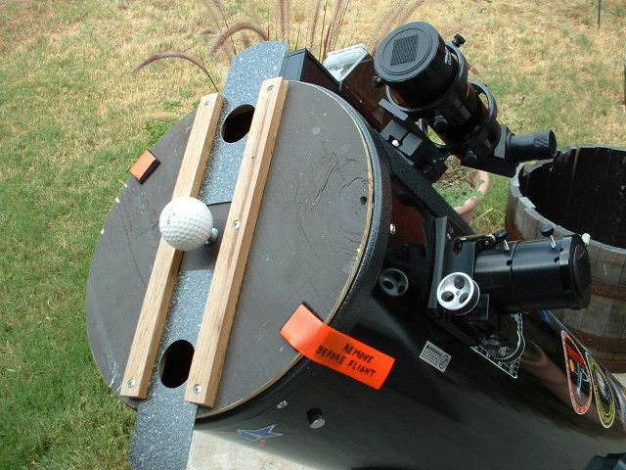
R. Herman
Figure 2. This prototype wooden mask has adjustable aperture separation. It is mounted on a Newtonian telescope.

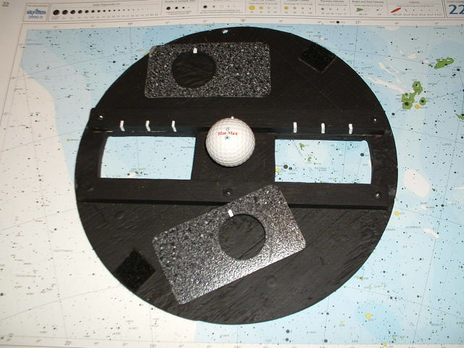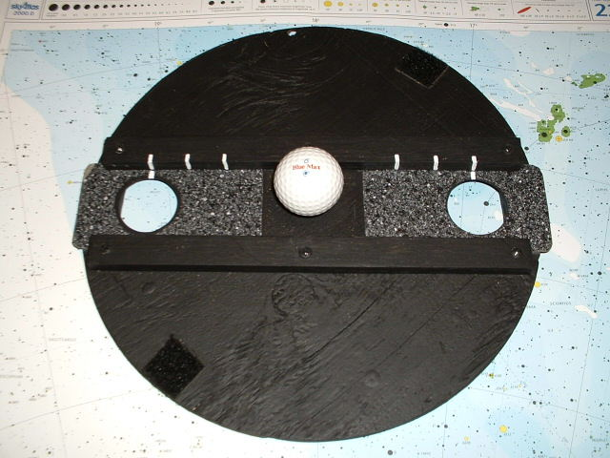
R. Herman

Figure 3. The as-built mask’s adjustable apertures are removed on the left and in place on the right. The slots permit light to come through the apertures wherever the sliders are positioned. The white marks make it easy to repeat the placement of the apertures. The apertures are offset in the sliders (made of kitchen counter laminate) so they can be inserted to allow both the minimum separation and be reversed for maximum separation without unwanted light going through the slots.
Hole size only matters in that a larger aperture lets in more light. If the mask is made with sliding apertures whose separation is adjustable, the hole size will limit the center-to-center separation possible and how much the separation can be varied. Diameters of 35 to 50 mm (1.5" – 2”) diameter are a good compromise (smaller for smaller telescopes, larger for larger ones). Additional sliders with smaller apertures can also be built for further experimentation.

- Eyepiece yielding 200x or more. Magnification is calculated by dividing the focal length of the telescope by the focal length of the eyepiece (both expressed in the same units):

M = $\frac{\text{Ft}}{\text{Fe}}$ (1)

If necessary, use a Barlow (negative relay) lens to increase the magnification to 200x or more if Fe is too large for M to be 200.

- Cross hair eyepiece, if desired, and Barlow (telemagnifying relay lens) to permit magnification to 200x or more with it, if necessary.

- Stop watch, if desired.

PROCEDURE: With the mask mounted on the telescope, a first look through an eyepiece at a bright out-of-focus star shows a pair of illuminated circles. Getting closer to focus, the circles move closer together in the field of view and become twin, bull’s-eye-like Airy patterns of disk surrounded by one or more rings (Fig. 4a). The patterns are more prominent than with the full aperture telescope because, when a smaller aperture lets in light, the light bends (diffracts) more sharply around the edges, making the disk larger. The high magnification provided by the eyepiece also contributes.

(The rings visible around the Airy disc are an interference phenomenon but not the one being demonstrated. They are caused by the circular aperture of the telescope itself. Just for fun, make a small, square aperture out of cardboard to put over the telescope and look at these "rings.")

At this point the telescope+eyepiece+eye are close to focus. As those patterns come together with final focusing, fringes (stripes) start to be visible when the “seeing” (the image smearing and motion caused by Earth’s atmosphere) merges the first rings of the Airy disks. When the Airy disks merge, the fringe pattern is easily visible (Fig. 4b). The fringes will be oriented perpendicular to the line between the initial out-of-focus, separate star images.

Keep playing with the focus, watching the Airy disk carefully for closely spaced stripes (fringes) to pop out in the star image's Airy disc. Steady seeing (i.e., low atmospheric turbulence) will allow you to see sharper images, making it easier to see fringes.

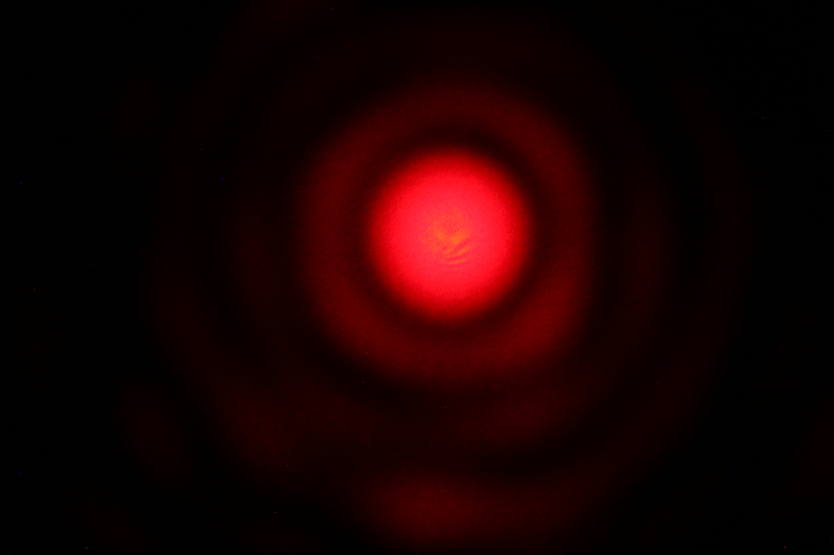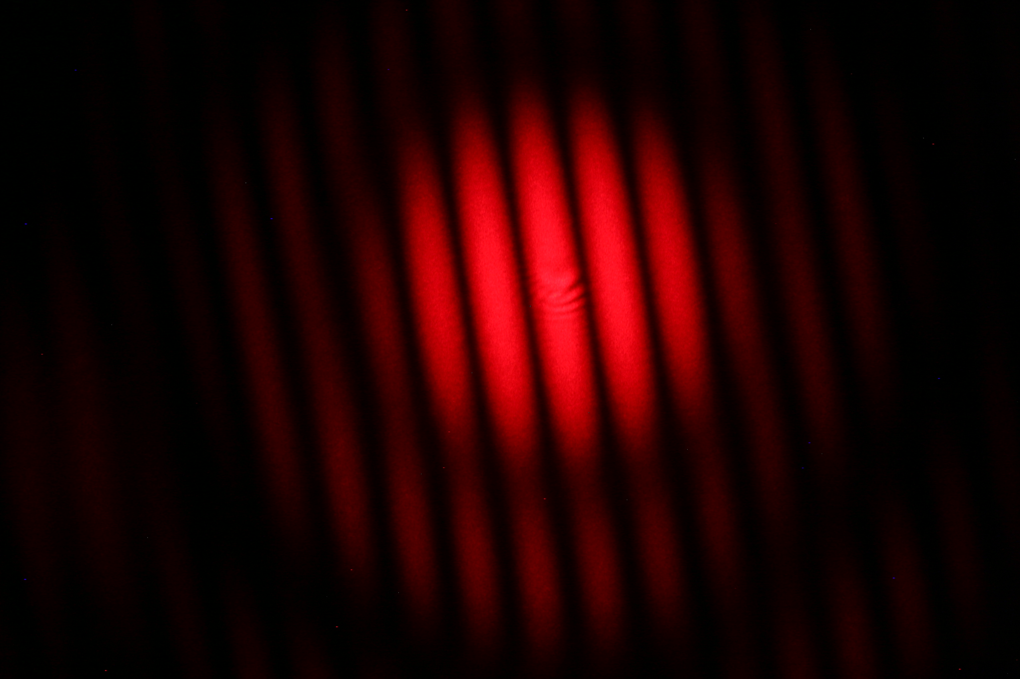

(a) (b)

Figure 4. These interference patterns were made with a laser but illustrate a highly magnified view of a star, as described below. In the telescope the patterns will appear white or only slightly tinted. Seeing these patterns is much easier than photographing them. (a) This single aperture interference pattern was made with a laser and a pinhole. It illustrates the Airy pattern seen by astronomers in their telescopes. (b) This is an interference pattern made with a laser and a pair of pinholes. Note how there are additional maxima and minima of brightness caused by the interference of light coming through the two holes. The single aperture pattern modulates the brightness of the double aperture pattern.

Experiment with different stars in the sky. There may be little or no variation between them, but the exploration is part of the intrigue. Larger interferometers with complex instrumentation do measure differences, important clues to the features of stars.

You might compare giants and main sequence stars, such as Betelgeuse and Rigel, Arcturus and Spica or Vega, Antares and Altair or Deneb or Vega, and Aldeberan and Capella. Try changing the separation of the apertures for these observations.

Look at Capella with the aperture pair in different position angles (it's an unresolved binary of Sun-temperature, sub-giant stars). Antares and Castor might show the influence of their companions on their fringes. Look for qualitative changes in the fringe pattern, especially contrast in the fringes and spacing between them. Keep track of your results by taking careful notes on what was seen and how. Changing the spacing of the apertures will change the spacing of the fringes, which the measurements would display. Look for fringes from Jupiter’s satellites and from stars of similar brightness. If you have an eyepiece with a reticle, you can make quite precise fringe measurements. See the Discussion and the Extension in the Appendix below.

DISCUSSION: Light waves entering a telescope are brought to focus by reflection off the curved, primary mirror or refraction (bending) of light by the objective lens. All the rays entering come to focus at the focal point. When they do, they interfere with each other and produce a small, tight Airy (bull’s eye) pattern. This pattern is the two-dimensional analog of a laboratory single-slit, linear interference pattern. When two smaller apertures are used in front of the telescope, the interference pattern is a striped line instead of a bull’s eye pattern, and that line is modulated by the larger Airy pattern generated by the smaller aperture(s).

The telescope interferometer system described thus far is analogous to the classic double slit experiment done in the lab. The slits in the lab and small apertures on the telescope are comparable. But the slits are spaced close together, making the interference pattern large and easy to see while the telescope apertures are widely spaced, making the interference pattern tiny (hence the need for 200x magnification). In both cases, light waves coming through the slits/apertures interfere when they combine, due to the differences in distances the waves travel.

The star image shows striping (fringes) perpendicular to the line between where the initial out-of-focus image disks appeared. More than one fringe is visible because the star image has a small but appreciable size due to its passage through the small aperture(s) at the front of the telescope. Combining the images (Airy disks) allows light from different portions of the disks to interfere across an area with a measurable size. The light has taken two different paths, of different lengths, to arrive at the same place. Because of the different path lengths, the light waves interfere.

It is interesting to note the implication of the Airy disk’s finite size for a full aperture telescope or one with a reduced aperture. It means that every telescope, no matter what its size, produces a small, but larger than infinitesimal, star image. There are no true point images. The physics of single aperture light wave interference requires an infinite aperture (hard to build!) to produce an image of a point source that is a mathematical point (infinitely small) at the focus of the telescope.

The properties of an object affect the appearance of its interference pattern. Equation (2) illustrates this:

For light passing through a double slit, the equation

sin θ = $\frac{n×λ}{d}$ (2)

describes the angle, θ, from the direction of the beam to the local brightness maxima, numbered n = 1, 2, … outward on either side of the maximum brightness spot (at the center, numbered zero) for a slit pair separated by d and a light source of wavelength λ. The wavelength is one factor determining the separation of the fringes so star color will affect the separation of its fringes. Changing the spacing of the entrance apertures changes the spacing of the fringes – widely separated apertures reduce θ and the fringe spacing, while closer apertures increase θ and widen the fringe spacing.

If a telescope-interferometer is close to resolving (separating) the components of a binary star system, the fringe pattern will show differences depending on the orientation of the apertures relative to the orientation of the pair of stars. If the apertures are oriented in the same direction as the star pair, the interferometer “sees” a larger object and this can reduce the contrast of the fringes. If the apertures are perpendicular to the orientation of the star pair the interferometer cannot distinguish the two stars so the interference pattern matches that of a single star. A detailed example of this is explored in the Appendix.

Alternatively, varying the separation of the apertures permits the observer to determine how point-like an object is for the telescope (interferometer). An object presenting fringes with the same contrast across the range of separation possible with the telescope is a point source for that telescope.

The story is much more interesting if the fringe contrast changes, and especially if the fringes disappear. When the fringes disappear, it means the object is not point-like even if it seems so by eye. The telescope’s apertures demonstrate it to be so large that interfering waves from across it wash each other out (peaks from some fall on valleys of others). Knowing the separation where washout occurs permits calculation of the object’s angular size. See the Appendix.

FOR MORE INFORMATION: PUMAS Example 09_21_05_1, Seeing Interference Fringes, gives instructions on making indoor observations of fringes.

There are links to the science, technology, and history of interferometry at http://planetquest.jpl.nasa.gov/SIM/sim_index.html.

ACKNOWLEDGMENT: This publication was prepared by the Jet Propulsion Laboratory, California Institute of Technology, under a contract with the National Aeronautics and Space Administration.

Reference herein to any specific commercial product, process, or service by trade name, trademark, manufacturer, or otherwise, does not constitute or imply its endorsement by the United States Government or the Jet Propulsion Laboratory, California Institute of Technology.

Appendix

EXTENSION: Fringe visibility (contrast; for this purpose, the difference between the maximum brightness of a fringe and the minimum brightness between fringes) gives an idea of the size of the object, i.e., whether the interferometer (or telescope) can resolve it. Point-like objects emit all their light from an (almost) infinitesimal source, so all the waves coming from them are “in step” and able to interfere with each other to the maximum amount possible. An object with some apparent size sends light from different parts of itself to the instrument and the waves from different portions may arrive “out of step” with each other to varying degrees so their interference is different from other sets of waves. When all the sets of interfering waves are added together, the fringe contrast is reduced.

Albert A. Michelson used this property to measure the size of a star. He added optics to make an interferometer on the Mt. Wilson 100" Hooker Telescope in 1921. He determined the aperture spacing that produced fringes and the largest spacing that didn't, and from that could deduce the angular diameter of the star.
It is possible to mimic Michelson’s star measurements by looking at Jupiter’s Galilean satellites. With the masked telescope, look for fringes from Jupiter's satellites (they won't be visible because the satellite disks are large enough to be resolved by the telescope) and compare that observation to the appearance of fringes from stars of similar brightness (similar brightness makes for easier comparison while the star’s unresolvable, nearly pinpoint image makes fringes visible). This will be challenging, because neither satellite nor star will be very bright. In fact, these observations copy experiments Michelson made with the 12" refractor at Lick Observatory in 1891. He got very good measurements of the diameters of the satellites this way, better than with competing methods right up to the Space Age.

If a crosshair eyepiece is available, make fringe spacing measurements by timing. Let a star's interference pattern drift across the hair and time the separation from minimum to minimum or maximum to maximum for different star colors. Tape record voice announcements of a fringe crossing the hair with radio time signals in the background, use a lap counting stopwatch, or have an assistant watch a second hand and write down the timings. Or simply start a stopwatch and count a number of fringes and then stop the watch to get a measure of fringes/second.

It is easy to convert fringes/second into an angular measurement. Since Earth rotates 360 degrees in 24 hours, this can be converted to 15 seconds of arc/1 second of time, 15”/s. Divide:

([number of fringes]/[time interval used])/15 = [fringe spacing in seconds of arc] (3)

A correction is necessary if the star being observed is not on the celestial equator: divide the result by the cosine of the star’s declination (the celestial equivalent of geographic latitude) for the final answer. Specifically,

fringe spacing [arc seconds] = $\frac{{\text{number}}_{{\text{of}}_{\text{fringes}}}\text{time}\text{_int}{\text{erval}}_{\text{used}}}{\text{15}×\text{cos}\left[\text{declination}\right]}$ (4)

Compare this to Dawe’s Limit, one method for predicting the resolution of a telescope. The Dawe’s Limit resolution in seconds of arc is

Resolution [arc seconds] = 114.3/[telescope diameter in mm] or (5a)

Resolution [arc seconds] = 4.5/[telescope diameter in inches] (5b)

The spacing of the fringes should be about the same as the resolution of the telescope.

If an eyepiece with measuring marks (like Celestron's Micro Guide or Meade's Astrometric eyepieces), or a real micrometer eyepiece is available, try measuring fringe spacing as a function of star color, star type, and aperture separation, separately. The reticle markings should be finely etched, though there will probably be several fringes between the closest markings, even with a Barlow lens in the optical path to increase the magnification of the star image (the Barlow won't magnify the reticle). Use the procedure above, timing the duration of a star’s drift between reticle marks, to calibrate the angular spacing of the marks with the telescope (and Barlow lens, if used).

