Document ID: 10_31_01_2
Date Received: 2001-10-31 Date Revised: 2002-01-16 Date Accepted: 2002-01-18

Curriculum Topic Benchmarks: M3.3.5, M8.3.1, M8.3.3, S11.3.1, S11.3.4, S11.3.5

Grade Level: [6-8] Middle School
Subject Keywords: wind chill, heat transfer, hypothermia, computation, exponents, cold weather, weather, winter, energy transfer, frostbite
Rating: Moderate
What is Wind Chill?
By: Peter Kiefer, Michigan Technology University, Houghton, MI 49931
email: pakiefer@mtu.edu

From: The PUMAS Collection http://pumas.jpl.nasa.gov
©2001, California Institute of Technology. ALL RIGHTS RESERVED. Based on U.S. Gov't sponsored research.

Why is it that we feel colder when the wind is blowing than when the wind is calm? What does it mean when the local weatherman gives the daily high along with the wind chill? How is the wind chill determined?

Everyone has experienced wind chill on one level or another. It is the reason why on a cold winter day we feel warmer when the wind is blocked by an object like a building than when exposed to the wind. It is on those winter days that the wind chill is most dangerous. The possibility of frostbite increases as the temperature drops or the wind speed increases. Thus it can be an average winter day, but if the wind speed is high enough, it can become very hazardous to be outside. This dangerous situation is present throughout the winters of the northern Midwest, where I am from. It’s common to receive wind chill warnings where exposed flesh can freeze in less than a minute.

Our bodies go through life trying to maintain one constant temperature. While it varies slightly from person to person, the average human body temperature is 98.6°F. Our bodies try to maintain this temperature regardless of the temperature of our environment. This is evident on a hot summer day when we sweat, or on a cold winter day when we shiver.

As a result of our bodies maintaining a constant temperature in a cold environment, a thin layer of warm air is trapped near our skin. This layer acts as a ‘buffer’ to the environmental temperature around us. If this layer were to be disturbed or destroyed, our body would have to work harder to maintain our body temperature since the ‘buffer’ air directly next to the skin is now colder. Since the ‘buffer’ air is colder, this makes us feel colder. It is for this reason that wind can make us feel colder. The stronger the wind, the more this ‘buffer’ layer is disturbed or even destroyed, making us feel even colder. The reverse is also true in that if we trap the ‘buffer’ air, we can make ourselves feel warmer (like a winter jacket).

The wind chill describes the sense of feeling colder due to wind. Paul Siple and Charles Passel did the first experiments in Antarctica in 1939. They experimented on the time it took water to freeze when exposed to the elements. They found out that the time for the water to freeze depended only the initial temperature (human body temperature), the environmental temperature and the wind speed. From their data they derived an empirical relationship, but it wasn’t a useful form for everyday use, so the National Weather Service uses a revised formula, given by:

WC = 35.74 + (0.6215 × T) – (35.75 × (ν ^{0.16})) + (0.4275 × T × (ν ^{0.16}))

Where WC is the wind chill index in Fahrenheit, ν is the wind speed in miles per hour and T is the temperature in Fahrenheit. This is easy to compute since the quantities are easily determined. It is from this equation that modern wind chill charts are constructed. The wind chill index gives the perceived temperature equivalent for the combination of cold air and wind. The following graph demonstrates the change in the perceived temperature for a range of wind speeds.

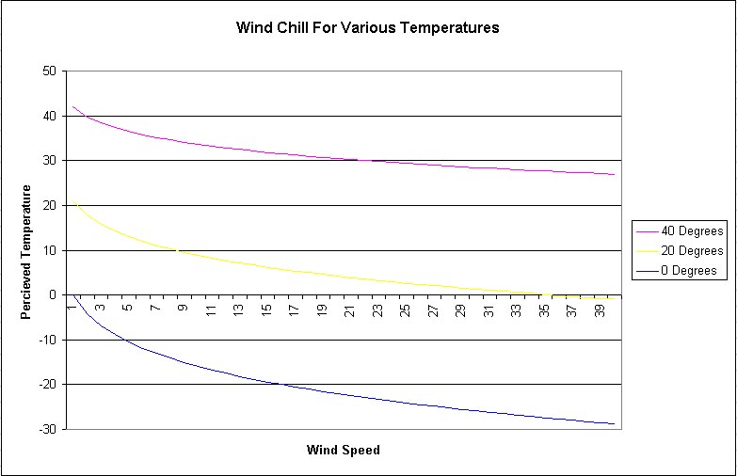

Wind chill is related to another dangerous wintertime occurrence, hypothermia. Both of these situations can become dangerous even in fair weather. Hypothermia can occur by two different means, either by wind or by the evaporative cooling of water. Both of these cool the body heated ‘buffer’ layer air near the skin. For activities associated with hypothermia see related PUMAS examples: Preventing Hypothermia and Hypothermia in the Little House.

Wind chill is dangerous because it can actually cause tissue to freeze in a process called frostbite. The severity of the wind chill is determined by the amount of time it takes for frostbite to occur on exposed flesh (this is why it is very important to cover your face and hands on days with low wind chills). Frostbite can occur in a matter of minutes, which makes wind chill an essential tool for forecasters to make people aware of the severity of the conditions outside.

Wind chill is only used to describe the perceived temperature for warm-blooded animals. An inanimate object exposed to the elements can only become as cold as the ambient temperature regardless of wind speed. If the object is at a different temperature than the ambient temperature the wind will aid in the cooling (or warming) of the object to the ambient temperature.

Activities:
Heat up two identical pie pans of sand (or any other similar object) such that there is a sufficient difference in temperature between the sand and the surrounding air. Place a thermometer in each pan of sand, and put one pan to the side and place the other pan by a fan so that the air is being moved across the sand’s surface (but not too close so as to make a mess). Contrast the differences in the temperature as the two pans of sand cool at different rates.

Calculate the wind chill that you might encounter in the Antarctic winter (average temperature of -71°F and wind speeds average more than 35 miles per hour). Compare this to the wind chill of an average winter day in your area. The wind chill can be calculated by using the wind chill equation. The temperature and the wind speed are the only values needed for the calculation. The order of operations is very important.

Example Calculation: ν = 30mph, T = -15°F
WC = 35.74 + (0.6215 × T) – (35.75 × (ν ^{0.16})) + (0.4275 × T × (ν ^{0.16}))
WC = 35.74 + (0.6215 × (-15)) – (35.75 × (30 ^{0.16})) + (0.4275 × (-15) × (30 ^{0.16}))
WC = 35.74 + (0.6215 × (-15)) – (35.75 × (1.723)) + (0.4275 × (-15) × (1.723))
WC = 35.74 – 9.323 – 61.605 – 11.050 = -46.24°F
Gives a wind chill of –46°F.

Use the local forecast of high and low temperatures along with predicted wind speeds to estimate wind chills for the current day.

Create a wind chill chart for a range of temperatures and wind speeds.

