Document ID: 12_04_01_1
Date Received: 2001-12-04 Date Revised: 2002-12-18 Date Accepted: 2002-12-20
Curriculum Topic Benchmarks: M1.2.1, M1.2.3, M1.2.6, M4.2.13, M5.2.1, M6.2.8
Grade Level: [3-5] Upper Elementary
Subject Keywords: contour, contouring, topo maps, topography, elevation, visualization,
map, landscape, estimation, 3 dimensions, 3 dimensional
Rating: moderate
Contouring and Topo Maps

By: Lorraine Remer Code 913, NASA/Goddard Space Flight Center, Greenbelt MD 20771 e-mail: remer@climate.gsfc.nasa.gov

From: The PUMAS Collection http://pumas.jpl.nasa.gov
©2002, California Institute of Technology. ALL RIGHTS RESERVED. Based on U.S. Gov't sponsored research.

Introduction: Twice during college I was taught to do hand contouring. One time in a meteorology class where the class was drawing isobars and isotherms on a weather map. One time in a geology class where we were drawing the topographical contours on an elevation map. I really enjoyed those exercises, but both times I remember thinking, “This is elementary school level.”

Contouring teaches both estimation and spatial visualization skills. To have experience visualizing 3 dimensional fields from a 2 dimensional map helps students throughout their mathematical career. You can’t start too soon, and it is so easy!

What is contouring?
. Contouring is drawing lines through a 2 dimensional array of numbers so that the lines connect all points of equal value. (Remember your “connect-the-dots” coloring books? That’s the basic idea.) In a topographic map these iso-lines (iso means same) are called contours and represent lines of constant elevation. On a weather map the iso-lines might be isobars and represent lines of constant air pressure, or isotherms, which are lines of constant temperature.

Figure 1 gives a simple example. Pretend you are flying above a hill and looking straight down. Each number represents the elevation in meters at a specific point on the earth’s surface. The line drawn through all the 25s represents a level path at constant 25 m that goes around the hilltop. The 25m line is easy to draw. The 20m line, representing a constant path at 20 m elevation, is a bit more difficult. You have to estimate where it will be 20m as you pass your pencil between the 15s and the 25s. It helps to visualize contours by imagining yourself walking along the contour. As you walk clockwise following the 20m line, everything to your left will be lower than you and everything to your right will be higher than you. The path you are on, the 20m line, will be perfectly level as you go around the hill.

Contour lines of the same value can connect and cross, but contour lines of different values can never intersect. Think about it. How can a point be 25 m elevation and 20 m elevation, simultaneously?

The contour interval is the spacing between contour lines. In Figure 1b I use a contour interval of 10 m. This means I draw contours for 10, 20 and 30 m. In Figure 1c I use a contour interval of 5 m. This means drawing contours for 5, 10, 15, 20, 25 and 30 m. The smaller the contour interval, the more contour lines there will be on the plot. Note that the contour plots change with contour interval, but the hill remains the same. You should be able to visualize the hill sticking out at you as you fly above.
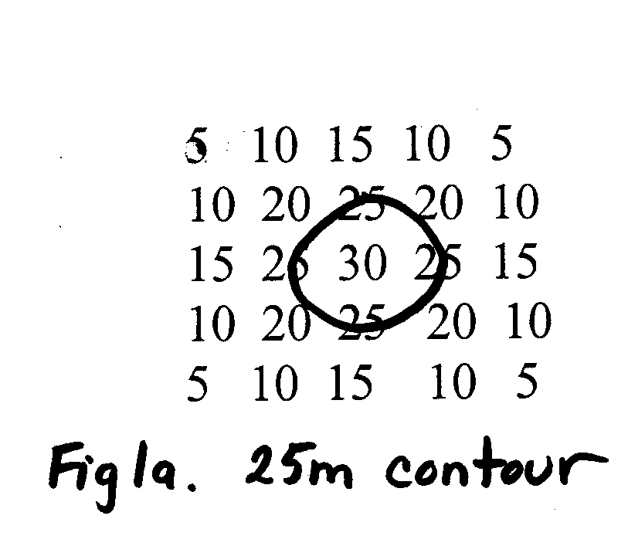
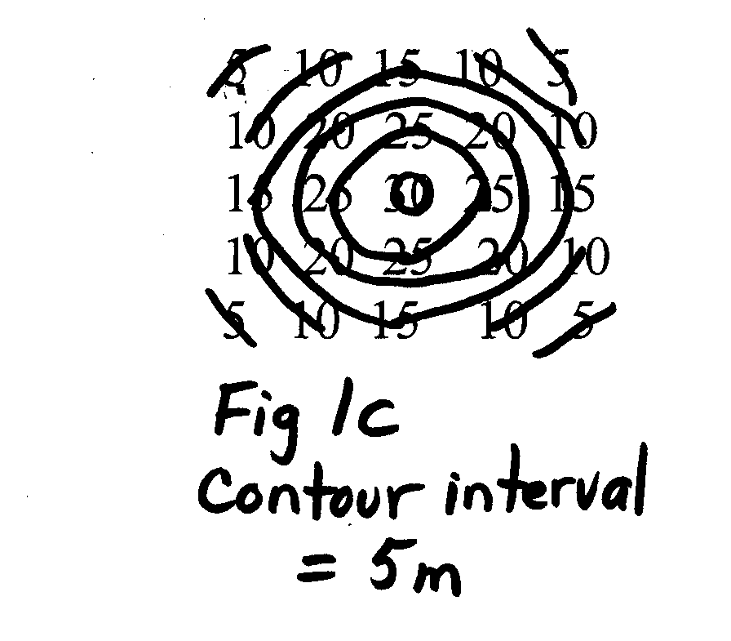
Figure 2 is a more complicated example. Here I’ve analyzed the contour field using a contour interval of 10. Can you visualize the ridge on the left and the plain to the right?

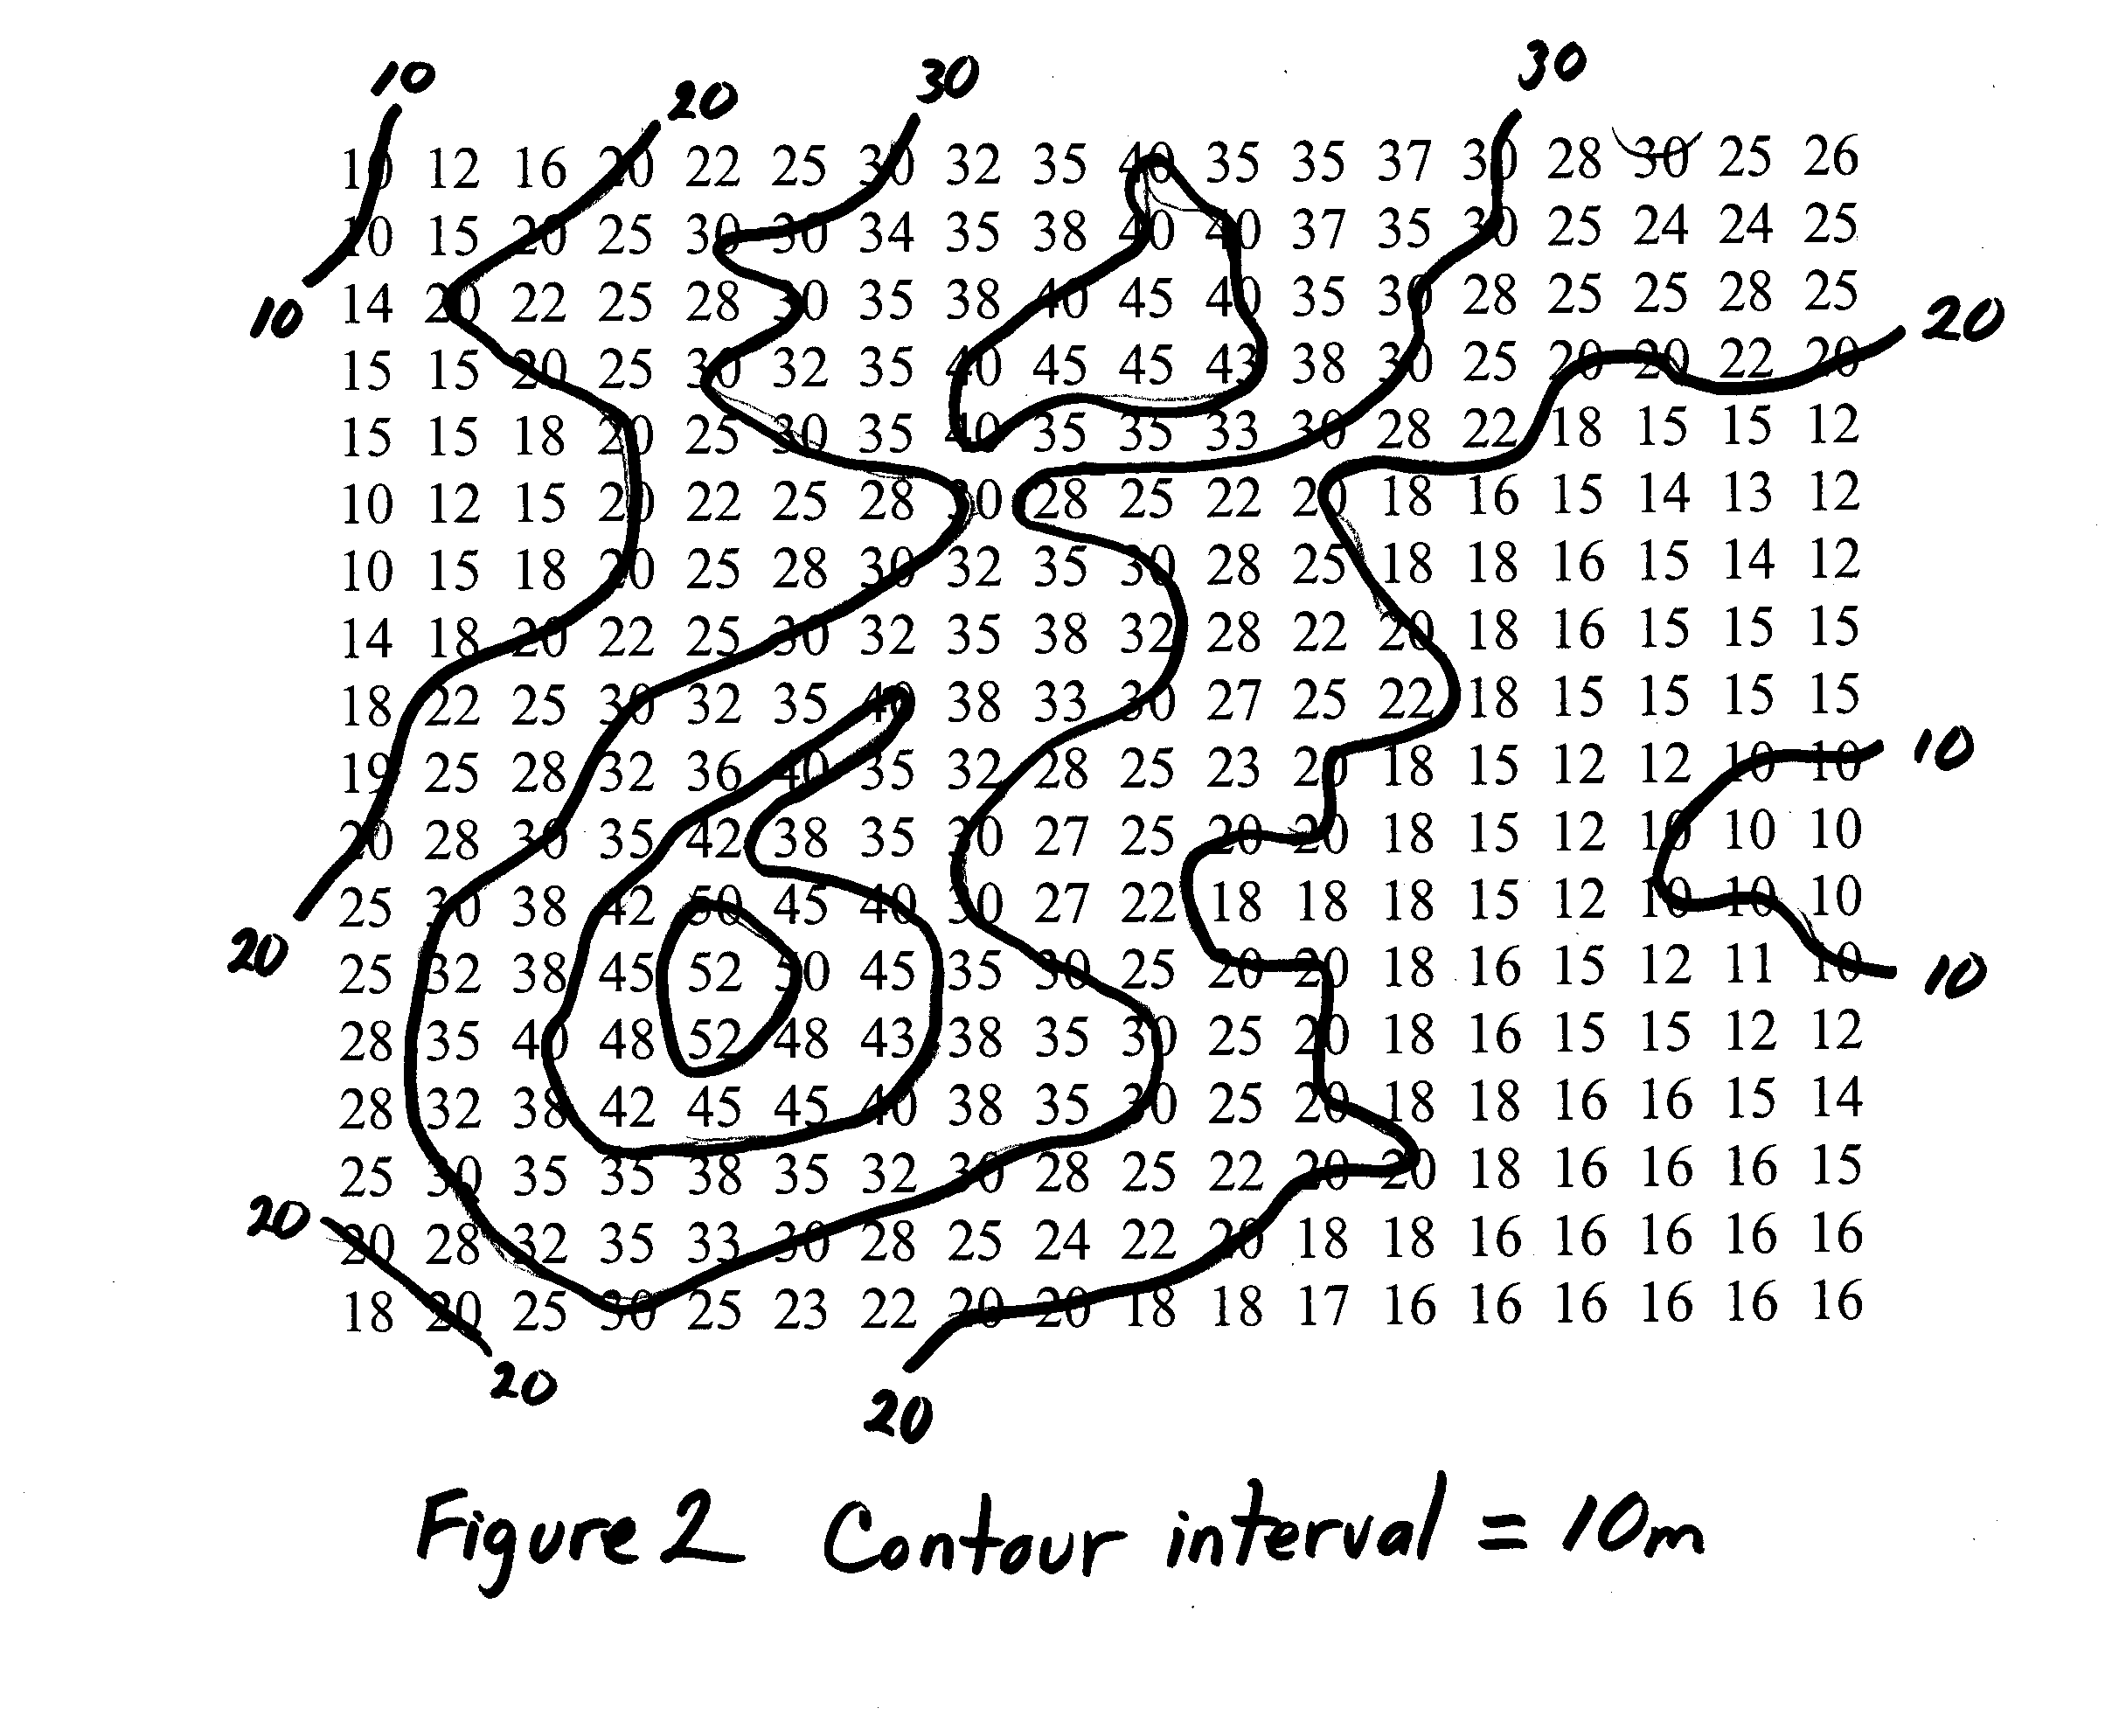

Suggested activities with a class:

- Make up arrays of numbers like in Figures 1 and 2. Have the students draw the contours at various contour intervals. These worksheets should get progressively harder.
- Make xerox copies of a portion of a USGS topographical map, and hand these out to the class. Have the class answer a series of questions about their maps. For example,
What is the elevation of a specific named feature on the map?
What is the lowest elevation on the map?
If I were to walk from point A to Point B, would I be walking uphill, downhill or on a level path?
What is the elevation gain if I walked from Point A to Point C? From C to D?
Which path is steepest? How do you know?
By the time they are done with the topo maps, the students should know uphill from downhill. They should recognize the contours as being level. They should understand that tightly packed contours are steeper slopes than widely spaced contours.
- . I live in Maryland. I took a page-sized outline map of Maryland and my AAA Tour Book and started looking up points of interest in the Tour Book. An elevation is given for each point of interest. I wrote the elevation down at the proper location on my blank Maryland outline map. Pretty soon the state of Maryland was covered in elevation numbers. I then could make copies and hand it out to the class. The class used a contour interval of 500 ft and drew in the contours for the state of Maryland. We then compared our contoured state of Maryland with physical maps showing elevation. Alternatively, you can get real digital topographic data from the USGS web site.
- Use your newspaper’s weather section to acquire the temperatures for sites across your region or cities across the U.S. Use a blank outline map and write the temperatures on the map in their proper locations. Have the class contour the isotherms. Compare with the newspaper graphics. Be sure to make the analogy between imaginary temperature surfaces represented by isotherms and the real land surface represented by contours on a topographic map. Be sure to point out that tightly packed isotherms are like steep slopes of elevation. These are places where the temperature changes quickly over a short distance.
- Make a color contour map. Start from one of the maps already contoured in (1) (3) or (4) above. Assign colors to represent different ranges of elevations or temperatures. Then ask the students to fill in the proper ranges with the proper colors.
- Make a 3-D model from Play-Doh. Make it look like a landscape. Develop a methodology to measure the surface height of the model at regular gridded intervals. (I used a marked toothpick). Transfer the numerical information to paper, and contour these numbers. Compare the 2-D contour plot with the 3-D model.

Cross Section and Slope

The next step is to do cross sections and calculate slopes. These I leave for a companion PUMAS example.

Note: A 44-page turn-key curriculum unit for this topic is available from the author.

